PERIODONTAL LIGAMENT
CONTENTS:
- INTRODUCTION
- DEVELOPMENT
- CELLS OF PERIODONTAL LIGAMENT
- FUNCTIONS OF PDL
- APPLIED ASPECTS
- REFERENCES

INTRODUCTION
- The periodontal ligament is a fibrous connective tissue. Present in between root of the teeth and the alveolus.
- Periodontal ligaments comprise cells as well as extracellular matrix.
- The average width of the periodontal space is said to be 0.2 mm.

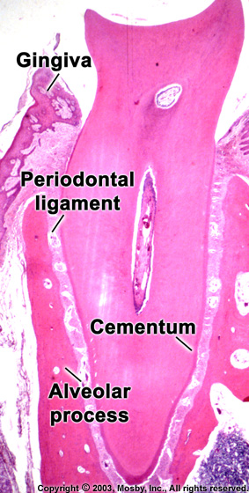

DEVELOPMENT
- Hertwig’s epithelial root sheath are surrounded by a condensation of cells the dental sac.
- Dental follicle is a thin layer of these cells that apparently is continuous with the cells of the dental papilla lies adjacent to the dental organ.
- Dental follicular cells are divided and differentiated into cementoblasts, fibroblasts and osteoblasts.
- The development of periodontal ligaments occurs after the cells of Herwig’s epithelial root sheath have separated forming the rest of Malassez.

- 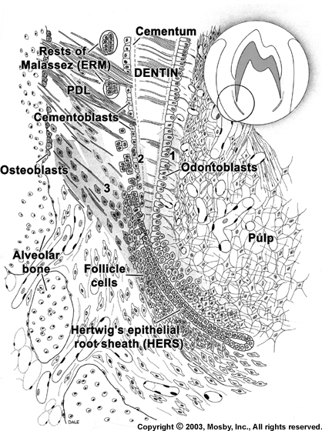

CELLS OF PERIODONTAL LIGAMENT

- Synthetic cells:-

    - Osteoblasts
    - Fibroblasts
    - Cementoblasts

- Resorptive cells:-
    - Osteoclasts
    - Fibroblasts
    - Cementoclasts

- Epithelial rest of Malassez

- Mast cells

- Macrophages
OSTEOBLASTS
- Osteoblasts are the bone forming cells.
- These cells lining the tooth socket.
- The cells contact with each other by desmosomes and gap junction.
CEMENTOBLASTS
- These cells are similar to osteoblasts.
- The appearance of cementoblasts will depend upon its degree of activity.

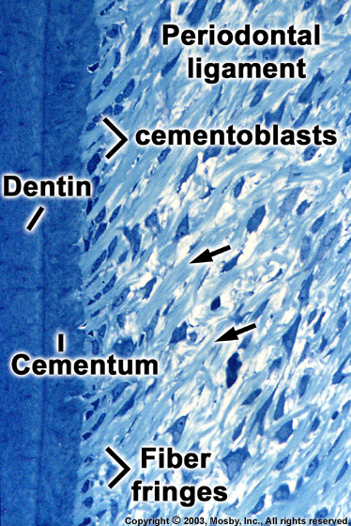
FIBROBLASTS
- Responsible for regeneration of the tooth support apparatus.
- Essential role in the adaptive responses to mechanical loading.
- Show variety of shapes.
- Periodontal fibroblasts are active cells.
- In periodontal ligament the fibroblasts also act as fibroclasts.

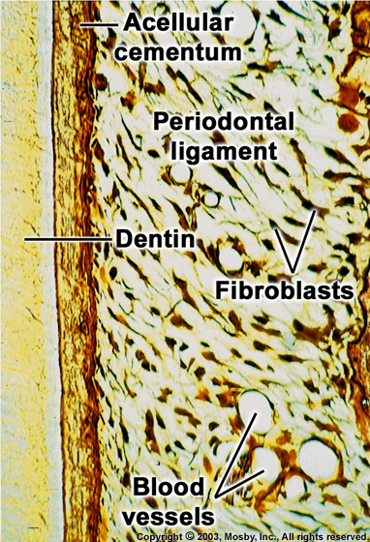

- The temporal sequence of intracellular digestion of collagen in the periodontal ligament:-
  - Collagen fibril first phagocytosed by fibroblast.
  - A banded fibril is surrounded by electron lucent zone.
  - Phagosomes fuses with primary lysosomes
  - Gradual increase in electron density
Fibril loses it’s characteristic structure

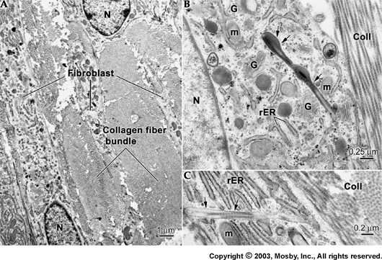

- Fibroblast in periodontal ligament secrets matrix metalloproteinase-1 (which degrades extracellular collagen at physiological condition).
- They also secrete tissue inhibitors of metalloproteinase (TIMPs) TIMPs found in high concentration at healthy periodontal ligament.
- Fibroblasts exhibiting myofibroblastic characteristics, specially abundant actin filaments and fibronexi are present.
- Fibroblasts contractility is responsible for the process of tooth eruption.
- Fibroblasts contractility probably is of greatest significance during posteruptive tooth movements.
OSTEOCLASTS
- Osteoclasts are cells that resorb bone and tend to be large and multinucleated. But can also be small and mononuclear.
- Resorption occurs in two stages:-
- First the mineral of bone is removed
- Then exposed organic matrix is disintegrated.
- Osteoclasts are seen regularly in normal functioning periodontal ligaments.
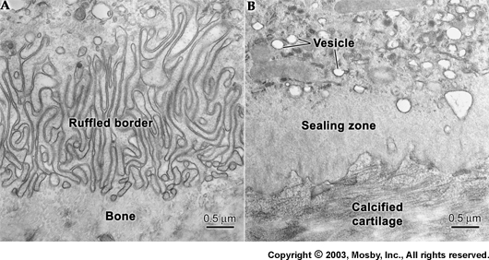

CEMENTOCLASTS
- Cementoclasts resemble osteoclasts and occasionally found in normal functioning periodontal ligament.
- Cementum is not remodeled in the fashion of alveolar bone and periodontal ligament but that is undergoes continual deposition during life.

Progenitor cells
- These are undifferentiated mesenchymal cells.
- These cells also known as totipotent cells.
- These cells contain small close faced nucleus and very little cytoplasm and are found in highest concentration close to blood vessels.

EPITHELIAL REST OF MALASSEZ
- They are remnants of HERS.
- They have slow turnover rate.
- These are close packed cells and their tendency to stain more deeply.
- The function of these cells are unknown.

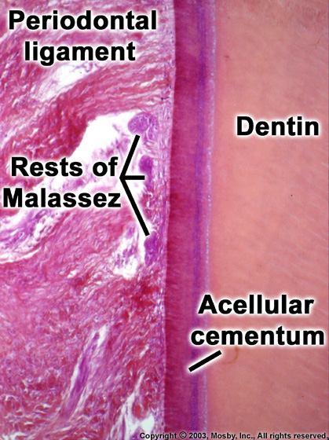
MAST CELLS
- Mast cells are defence cells of periodontal ligament.
- Functionally and structurally they are similar to basophils.
- When the cell is stimulated it degranulates.

MACROPHAGES
- These type of defence cells make up about 4% of the periodontal ligament cell population.
- They are responsible for phagocytosing particulate matter and invading organisms.
- They also synthesize molecules like interferon, prostaglandin, and other factors that enhance the growth of fibroblasts and endothelial cells.
- Macrophages are derived from the blood monocytes.

EXTRACELLULAR SUBSTANCES
- The extracellular substances of the periodontal ligament comprises the following:-
- Fibers:
  - Collagen
  - oxytalan
- Ground substances:
  - Proteoglycans
  - glycoproteins
COLLAGEN
- The majority of fibers in the periodontal ligament are collagen.
- Periodontal ligament appears to be made up predominantly of type I and type III.
- Collagen macromolecules are rod like structures.
- Fibers of Collagen are gathered to form large bundles and these are readily resolved by light microscopy.
- these bundles having clear orientation relative to the periodontal space, these are termed principal fibers.
PRINCIPAL FIBERS
- Alveolar crest group
- Horizontal group
- Oblique group
- Apical group
- Interradicular group
SHARPEY’S FIBERS
- Embedded periodontal fibers in cementum and alveolar bone is known as Sharpey’s fibers.
- These are partially mineralized structures.
- The degree of mineralization and orientation of these fibers varies in alveolar bone and cementum.
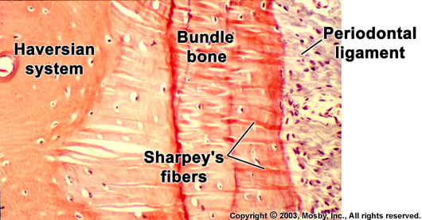

- Although not strictly part of PDL other group of fibers are associated with maintaining the functional integrity of the periodontium. They are found in the lamina propria of the gingiva and collectively form the gingival ligament.

- Five groups of the fiber bundles compose this ligaments:-
1. Dentogingival fibers
- Alveologingival group
- Circular group
- Dentoperiosteal group
- Transseptal fiber system

Transseptal ligament
These fibers run interdentally from the cementum just to the base of the junctional epithelium of one tooth over the alveolar crest and insert into a comparable region of the cementum of the adjacent tooth.
Together these fibers form transseptal fiber system, collectively forming an interdental ligament connecting all the teeth of the arch.
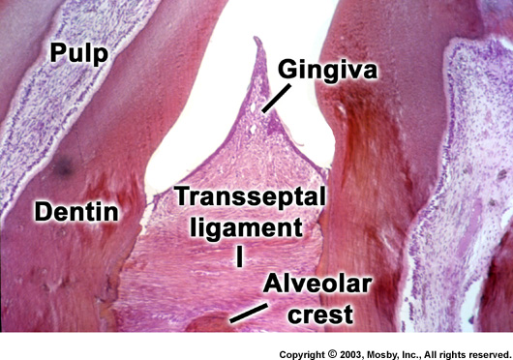

OXYTALAN
- Oxytalan are immature elastic fibers.
- The orientation of the oxytalan fibers is quite different from that of the collagen fibers.
- The function of these fibers are unknown.

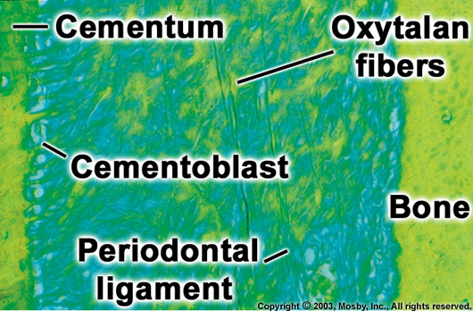

GROUND SUBSTANCE
- The space between cells, fibers, blood vessels and nerves in the periodontal space is occupied by ground substance.
- Existence of ground substance in PDL is important for metabolism of cells.
- The ground substance is made up of two major groups of substances, proteoglycans and glycoproteins.
- Fibronectin, a type of glycoprotein is uniformly distributed in PDL
STRUCTURES PRESENT IN PRIODONTAL LIGAMENT
- The following discrete structures is present in the connective tissue of the periodontal ligament:

    - Blood vessels
    - Lymphatics
    - Nerves
    - Cementicles

BLOOD VESSELS
- The arterial vessels of the periodontal ligament are derived from three sources:
  - Branches of apical vessels.
  - Branches from intra-alveolar vessels.
  - Branches from gingival vessels.
- Vessels course in apical-occlusal direction with numerous transverse connections.
- Fenestrated capillaries occur.
- 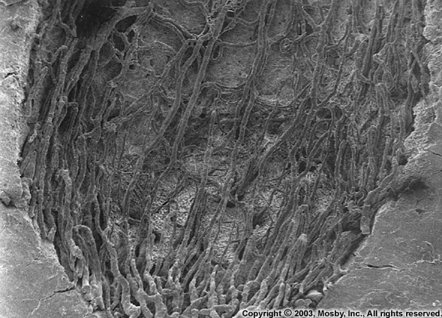
LYMPHATICS
- A network of lymphatic vessels, following the path of the blood vessels, provide the lymph drainage of the periodontal ligament.
- The flow is from the ligament toward and into the adjacent alveolar bone.

NERVES
- The nerve fibers supplying the periodontal ligaments are functionally of 2 types:
  - Sensory
  - Autonomic
- The nerve fibers entering the PDL is derived from two sources
  - From near the root apex
  - Fine nerve fibers from alveolar wall.

- Four types of nerve endings are present :
  - Tree like ramifications
  - Ruffini’s endings
  - Coiled endings
  - Encapsulated spindle type endings.
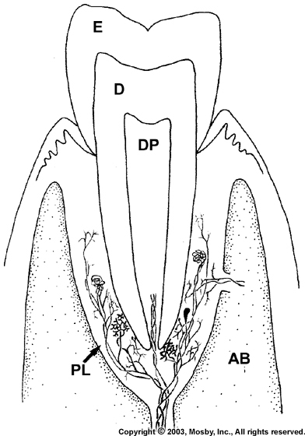
PERIODONTAL LIGAMENT HOMEOSTASIS
- Remarkable capacity of the periodontal ligament is that it maintains its width more or less overtime despite the fact, that it is squeezed in between two hard tissues.
- Various molecules have been proposed which play a role in maintaining an unmineralised periodontal ligament.
  - Msx2 prevents the osteogenic differentiation of periodontal ligament fibroblasts by repressing Runx2
  - The balance between the activities of bone sialoproteins and osteopontin may also contribute in maintaining an unmineralised periodontal ligament region.
  - Matrix ‘Gla’ protein, an inhibitor of mineralization is also present in periodontal ligament.
  - Glycosaminoglycans also play a role in maintaining of unmineralised state of periodontal ligament.

Functions of periodontal ligament
- It forms the tooth support mechanism.
- The mechanoreceptors are involved in the neurological control of mastication.
- Maintain and repair alveolar bone and cementum.

Clinical consideration
- The most important clinical condition affecting the periodontal ligament is chronic inflammatory periodontal disease.
- Important changes also take place within the periodontal ligament with orthodontic loading.
- For the practice of restorative dentistry the importance of PDL thickness is obvious.

The clinical manifestations of the periodontal diseases results from a complex interplay between the etiological agents, mainly specific bacteria found in dental plaque, and the host tissues. Thus it describes the many different factors, locally or systemically that can influence the course of disease by modifying the processes inherent in the bacterial – host interaction.
Inflammation is the central pathologic feature of periodontal disease and bacterial plaque is that etiologic factor responsible for inducing the host inflammatory processes.
Gingivitis and periodontitis as well as other less common periodontal diseases are chronic bacterial infections. As in other infections, the host - bacterial interactions determine the nature and extent of the resulting disease. Pathogenic microorganisms may influence the course of the disease process by producing tissue – toxic substances, by directly invading host tissues and by stimulating a host response.

Classification
Gingival diseases
- Plaque induced gingival diseases.
- Non-plaque induced gingival lesions.

Chronic periodontitis
- Localized
- Generalized

Aggressive periodontitis
- Localized
- Generalized

Periodontitis as a manifestation of systemic diseases
Necrotizing periodontal diseases
- Necrotizing ulcerative gingivitis (NOG)
- Necrotizing ulcerative periodontitis (NOP)

Abscesses of the periodontium
- Gingival Abscess
- Periodontal Abscess
- Peri-coronal Abscess

Periodontitis associated with endodontic lesions
- Endodontic periodontal lesion
- Periodontal endodontic lesion
- Combined lesion
Contributory factors in periodontal disease
- Contributing local factors
  - Plaque retention factors
    - Calculus
    - Food impaction and retention
    - Open and loose contacts
    - Overhanging margins and restorations
    - Poorly designed or fitted prosthesis
    - Soft or sticky consistency of diet
    - Mouth breathing ; incomplete lip closure

  - Anatomic predisposing
    - Tooth mal allignment, malposition, altered anatomy.
    - High frena or muscle attachments
    - Shallow vestibule
    - Insufficient gingival width
    - Thin, finely textured gingiva
    - Thick, bulbous gingiva margins

  - Tissue trauma
    - Tooth brush trauma
    - Injurious habits (tooth picks)
    - Improper dental treatment methods
    - Other injury

  - Functional periodontal trauma
    - Muscle hyper tonicity
    - Bruxism
    - Clenching and clamping
    - Excessive loads on abutment teeth
    - Unfavorable crown-root ratio
    - Plunger cusps
    - Mobility
    - Drifting of teeth

- Contributing host factors
  - Immunologic defects (Including polymorphonuclear cell defects)
    - Chediak – Higashi syndrome
    - Down syndrome
    - Lazy leucocyte syndrome
    - Juvenile periodontitis

  - Endocrine dysfunctions
    - Puberty
    - Pregnancy
    - Post menopausal
    - Hyper thyroidism
    - Hypothyrodism
    - Juvenile diabetes mellitus

  - Metabolic, genetically transmitted disease
    - Diabetes
    - Hyperkeratosis palmoplantaris
    - Hereditary agranulocytosis
    - Hypophosphotasia

  - Psychotomatic or emotional disorders
    - Fatique
    - Stress

  - Drugs and metallic poisons
    - Phenytoin (Dilantin)
    - Corticosterioids
    - Smoking

  - Nutrition and diet
    - Hypervitaminosis A & D
    - Protein caloric malnutrition
    - Scurvy

Calculus has long been considered to have an important role in the development, promotion and recurrence of gingival and periodontal infections.

- Relation to plaque
  - Calculus is mineralized plaque. Therefore, calculus prevention depends on plaque prevention.
  - Calculus has a rough surface and provides a medium for plaque collection on its surface.

- Relation to pocket
  - Sub gingival calculus is always covered by active plaque that is in direct contact with the pocket epithelium. Plaque bacteria initiate gingivitis and periodontitis.
  - With the perpetuation of inflammation in the pocket wall by the plaque on the surface. The secretion of gingival sulcus fluid is promoted and increased. With more fluid, come more minerals for calculus formation.
  - Friedman designates calculus as a dynamic destructive agent since it is a foreign body that is held in constant contact with the pocket wall.
- Permeability of calculus:
With its rough structure (surface) and permeable structure, calculus can act as a reservoir for toxic products. Adjacent to the pocket lining and inflammation can persist.
- Drainage from diseased pocket:
Calculus can reduce drainage from the pocket by helping to trap bacterial debris. Healing is prevented and the advancement of disease is encouraged. Gingival abscess formation may result.
BONE RESORPTION
Loss of alveolar bone is the most critical aspect of inflammatory periodontal disease with regard to tooth loss. In periodontitis bone loss may be of a generalized horizontal type in which all the teeth are affected more or less equally or isolated bone craters affecting single teeth may be seen. While substances derived from microbial plaque or specific microorganisms residing in periodontal pockets are ultimately responsible for triggering bone loss. The means by which this occurs remains an enigma. Microbial substances may affect bone directly, causing differentiations of osteoclasts and restoration, or these substances may inhibit bone formation. Further more the effects of microbial substances may be achieved through activation of other cells such as lymphocytes and macrophages to produce substances that affect bone, although there has been great interest and a flurry of research in attempting to achieve bone regeneration with grafts and transplants.
Substances of three types have been identified as inducers of bone resorbtion in vitro. These include
a). Microbial material from dental plaque.
b). Substances extracted from gingiva.
c). Factors generated by activation of the immune system and complement. cascade
First type includes endotoxin derived from gram-negative bacteria. Lipoteichoic acid from the cell wall of gram-positive microorganisms and a soluble extract of whole plaque. The activity of endotoxin and Lipoteichoic acid residues in the glycolipid portion of the molecule, heparin a component of mast cells that is released during injury does not have the capacity to induce bone resorption directly, although it is a potent enhancer of resorption by endotoxin and other microbial substances. Other substances classically associated with the acute inflammatory response. Including bradykinin, histamine and Lysosomal enzymes are unable to stimulate resorption.
Complement sufficient serum, but not complement deficient serum has the capacity to induce resorption presumably through its activation by immune complex. Complement activation leads to an increase in prostaglandin levels in the cultures that parallels increased resorption, both prostaglandin production and bone resorption can be prevented by the addition of indomethacin an inhibitor of prostaglandin synthetase to the culture medium. Whether bacterial substances such as endotoxin that induce bone resorption act via the alternate pathway of complement activations and prostaglandin production of remains unknown.
Activation of the immune system also appears to have the potential for causing bone resorption. Horton and his colleagues have shown that peripheral blood leucocytes from normal or periodontalally diseased individuals stimulated with mitogen phytohemagglutinin and leucocytes from individuals with periodontal disease stimulated with plaque antigens undergo blast transformation and produce a lymphokine which is a potent stimulator of bone resorption. This substances that has not been further characterized, has been called Osteoclast activating factor. (OAF).

REFERENCES

