E - CONTENT

IMMUNITY AND INFLAMMATION – BASIC CONCEPTS

INTRODUCTION :
The state of periodontal health or disease depends upon the interaction between the resident microbiota and the host response.
Periodontal pathogens trigger both inflammatory reaction and host immune response.
The immune system plays a key role in limiting the infections to the gingival crevice. It also orchestrates the alterations of the connective tissue in a complex remodeling process involving cycles of destruction and reconstruction.
.
TYPES OF IMMUNITY
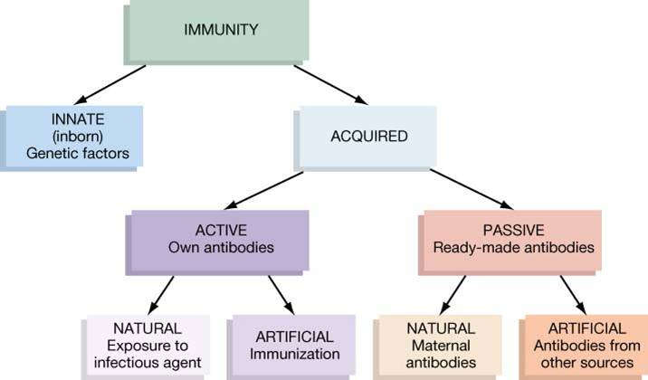
Broadly, the different types of immune responses fall into two categories
- Natural / innate immunity
- Acquired / adaptive immunity

- Natural or innate (Non specific) which includes first line of defense against invasion by microbes.
  - Refers to any inborn resistance that is present the first time a pathogen is encountered; it does not require prior exposure and is not modified significantly by repeated exposures to the pathogens over the life of an individual.
The responses include inflammation, phagocytosis by leukocytes, natural killer cells, tissue secretion and complement.

- Acquired or adaptive immunity, which is (specific) refers to resistance that an individual acquires during his lifetime, which may be weak or absent on first exposure but that increases dramatically with subsequent exposures to same specific pathogen.
  - Acquired immunities are of two types, active and passive.
    - Active immunity is the resistance developed by an individual as a result of an antigenic stimulus. This involves that active functioning of persons immune apparatus leading to the synthesis of antibodies and/or the production of immunologically active cells.
    - Passive immunity is the resistance that is transmitted to a recipient in a readymade form. There is no antigenic stimulus, instead preformed antibodies are administered.

There are two types of effecter mechanisms that mediate specific immune responses:
a) Humoral immunity
b) cell-mediated.

  - Humoral immune responses are those mediated by a cell product of the lymphoid tissues referred as antibody. Humoral immune reactions are associated with the fluid phase of blood (plasma or serum).

  - cell mediated are those mediated by specifically sensitized lymphocytes themselves.

CELLS OF IMMUNITY AND INFLAMMATION
Mast cells:
The mast cells are important in immediate inflammation. they possess receptors for complement components (C3a and C5a) as well as receptors for the Fc portion of the antibody molecules IgE and IgG (Fc R and FcR respectively). The stimulation of these receptors can result in activation and secretion of vasoactive substances that increase vascular permeability and dilation. Mast cells possess granules, which contain histamine, heparin, eosinophil chemotactic factor and neutrophil chemo tactic factor. Mast cells can synthesize mediators such as slow-reacting substances of anaphylaxis (SRS-), tumor necrosis factor (TNF-) and leukotriene C4.

Dendritic Cells:
Peripheral dentritic cells are leukocytes with cytoplasmic projections, or dendrites. The cells have a diameter of 9 to 10 m in blood. Langerhans cells are dendritic cells that reside in the suprabasilar region of the squamous epithelium. Along with macrophages, the dendritic cells function as antigen presenting cells. They ingest the antigen locally and transport it to the lymph nodes through afferent lymphatics

Mononuclear phagocytes:
The mononuclear phagocyte system has two main functions, which result from the activities of two different types of bone marrow derived cells.
- ‘Professional’ phagocytic macrophages, whose main role is to remove particulate antigens.
- Antigen presenting cells, whose role is to take up, process and present antigenic peptide to T cells.
Macrophages are highly phagocytic cells which are part of scavenger reticuloendothelial system.
Macrophages secrete molecules, engulf and remove excess antigen and aid in the induction of immune response of presenting determinants to T cells. An organism that successfully penetrates an epithelial surface encounter phagocyte cells of the monocyte macrophage lineage.

Polymorphonuclear granulocytes:
PM nuclear granulocytes mainly consist of neutrophils and differentiate completely with in bone marrow (14 days) are released from the bone marrow at a rate of around 7 million per minute. Neutrophils comprise over 95% of circulating granulocytes. Chemotactic stimuli result in neutrophil margination and diapedesis. Neutrophils have a large arsenal of antibiotic proteins stoned in two main types of granules. The primary granules are lysosomes containing acid hydrolysis, myeloperoxidase and muranidase (lysozyme). The secondary granules contain lactoferrin and lysozyme. In addition the granules also contain the antibiotic proteins defensins, seprocidins, cathelicidins and bacterial permeability inducing proteins.

Lymphocytes :
lymphocytes includes three types of cells.
- T-lymphocytes or T cells, which are derived from the thymus and play a role in cell-mediated immunity.
- B-lymphocytes or B-cells which are derived from liver, spleen and bone marrow are the precursors of plasma cells and play a role in humoral immunity.
- Natural killer (NK) and killer (K) cells.

T lymphocytes are generated from immature precursors in the thymus. Each T cell is
genetically programmed to recognize a specific cell-bound antigen by means of an antigen-specific T-cell receptor
(TCR). T-cells may be divided further, according to their functions.
T-cells
Regulator cells Effector cells
Helper/Inducer Suppressor Cytotoxic cells Mediate
Cell cells (CD8) delayed
(T4/CD4) (T8/CD8) Kills target hypersensitivity
Helps in antibody Inhibits certain cells
formation immune responses
65% of circulating 35% of circulating

B-cells:
B cells are bone marrow derived lymphocytes. B cells recognize diverse antigens using the B-cell antigen receptor (BCR). The high-affinity interaction between the BCR and antigen enables the B-cells to bind and ingest the antigen without antigen presentation.
On contact with its appropriate antigen, majority of B cells are transformed into plasma cells, while some activated B cells become long lived memory cells responsible for the recall phenomenon seen on subsequent contact with the same antigen. Plasma cell is the antibody-secreting cell.

By entry of antigen,
Macrophage phagocytoze the antigen
Provides the antigen to
B lymphocytes (Activation)
T lymphocytes
helper T cell
(also contribute for activation)
Specific B lymphocyte activate,
differentiate into plasma cells
It produces immunoglobulins, this antibodies are secreted in lymph.
Then to circulating blood.

Natural killer cells: NK cells are endowed with an innate ability to kill a variety of tumor cells, virally infected cells.
These cells are part of the innate immune system, and they may be the first line of defense against viral infections and, perhaps, some tumors.
The functional activity of NK cells is regulated by a balance between signals from activating and inhibitory receptors. The activating receptors stimulate NK cell killing by recognizing ill-defined molecules on target cells, some of which may be viral products; the inhibitory receptors inhibit the activation of NK cells by recognition of self-class I MHC molecules.

THE COMPLEMENT SYSTEM

- The term “ complement ” refers to a system of factors which occur in normal serum that are activated characteristically by Ag-Ab interaction and subsequently mediate a number of biologically significant consequences.
- Complement is normally present in sera in inactive form but when activity is induced by antigen-antibody combination, C components react in a specific sequence as a cascade

- There are three pathways of complement activation-
- Classical pathway.
- Alternative pathway
- Lectin pathway

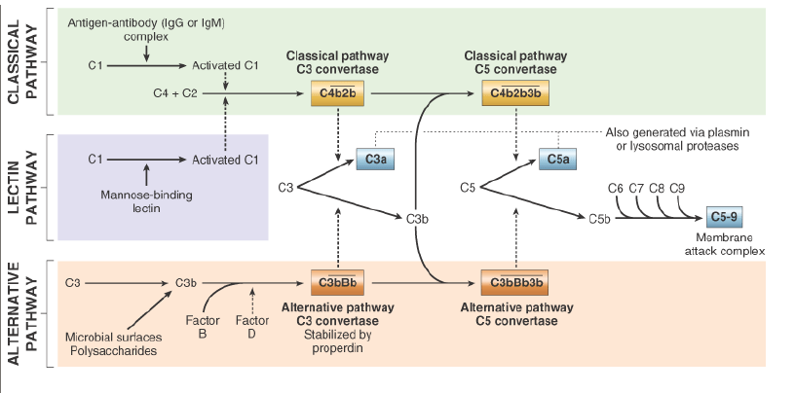
Classical pathway :
Steps :
- First step is the binding of C1 to the antigen-antibody complex
- Activated C is cleaves C4 and into C4a, and C4b.
- C1 4b in the presence of magnesium ion cleaves C2 into C2a which remains linked to cell bound C4b and C2b which is released into fluid phase
- Enzymatically activated C4b2a is referred as the classical pathway C3 convertase.
- C3 connection splits C3 into two fragments – C3a which is an anaphylatoxin and C3b which remains cell-bound along with C 4b2a to form a tri molecular complex C 4b2a3b which has enzymatic activity and is called C5 convertase.
- The membrane attack phase begins at this stage with C5 covertase cleaving C5 into C5a, an anaphylotoxin which is released cleaving C5 into C5a, an anaphylotoxin which is released and C5b which continues with the cascade C6 and C7 then join together.
- A C567 complex is formed, part of which binds to cell membrane and prepares it for lysis by C8 and C9
- The mechanism of complement mediated cytolysis is the production of 'holes' approximately 1000 in diameter on the cell membrane. This disrupts the osmotic integrity of cell membrane, leading to the release of cell contest.

Alternate pathway :
The central process in the complement cascade is the activation of C3 which is the major component of C. In classical pathway, activation of C3 is achieved by C 42 (classical C3 convertase). The activation of C3 without prior participation of C142 is known as the ‘alternative pathway.
The first step in the alternative pathway is the binding of C3b which is cleaved from C3 to an activator. Bound C3b interacts with a serum protein called factor B to form a magnesium dependent complex ‘C3b,B’.
The C3bB complex is inactive, however, in the presence of component D (C3 proactivator converter) the complex is converted to C3b. Bb which is similar to the C3 convertase (C142) of the classical pathway.

BIOLOGICAL EFFECTS OF COMPLEMENT
Promotes inflammation by generating the following; (Carranza 2007)
  - A Kinin-like, C2a, induces pain and increases vascular permeability and dilation
  - Anaphylotoxins, C3a and C5a, which produce anaphylaxis by inducing mast cell secretion
  - A Chemotaxin, C5a, which attracts leukocytes and stimulates phagocyte secretion
  - An Opsonin, iC3b, covalently bound to molecular aggregates particles or cells, which enables phagocytes to ingest them.

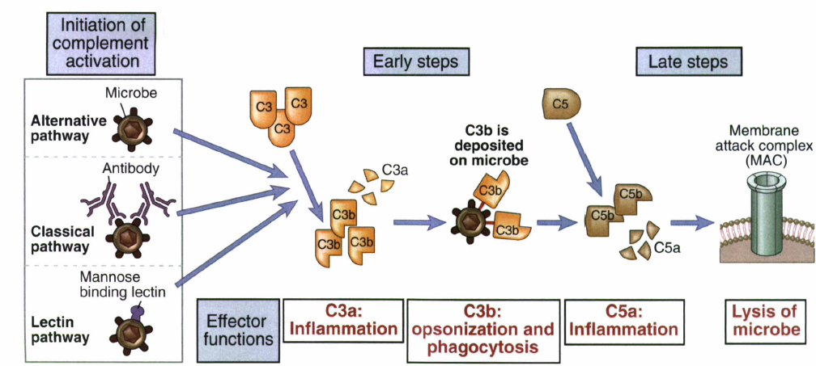

TRANSENDOTHELIAL MIGRATION
The sequence of events in the extravasations of leukocytes from the vascular lumen to the extra vascular space is divided into
- Margination and rolling
- Adhesion and transmigration between endothelial cells
- Migration in interstitial tissues toward a chemotactic stimulus.

Margination and rolling
- Normal laminar flow occurs, where discoid RBC’s move faster and the WBC’s are pushed out of the central axial column.
- Slowing (stasis) and loss of fluid augments the process of interaction between WBC and endothelial cells.
- The process of leukocyte accumulation at the periphery of vessels is called MARGINATION.
- Subsequently, leukocytes tumble on the endothelial surface, transiently sticking along the way, a process called ROLLING.
Leukocytes use lectin (a non – enzymatic carbohydrates binding protein), designated L – selectin, to interact with the carbohydrate molecules on the luminal surface of endothelial cells -> ROLLING.

Adhesion and Transmigration
- Local insult -> release of inflammatory signals (IL – 1, TNF) C_{5a} and LPS -> stimulate endothelial cells to express P – selectin and E – selectin on their luminal surfaces -> increasing binding of leukocytos -> increasing rolling.
- Stimulated endothelium release CHEMOKINES [small peptide cytokines], which play a fundamental role as selective signals for leukocytes to exit blood.
- Chemokines example: IL – 8 -> cause leukocyte to shed the L – selectin, upregulate the integrin [Leukocyte function associated antigen – 1 (LFA –1)] which binds to inter-cellular adhesion molecule – 2 (ICAM – 2), which is expressed constitutively by endothelium. This causes rolling arrest and firm adhesion of leukocytes on endothelial wall
- After firm adhesion -> transmigration of leukocytes by squeezing between cells at intercellular junctions. This occurs with help of CD₃₁ (Platelet – endothelial cell adhesion molecule – 1).
CD₃₁ expressed by both endothelial cells facing the lumen and all leukocytes.
Once leukocyte locates the intercellular junction, it uses its own CD₃₁ like a zipper [CD₃₁ zipper] with the CD₃₁ of endothelial cells.
- Leukocytes accumulate briefly between the basement membrane and the endothelial cell -> secretion of proteases to degrade the basement membrane
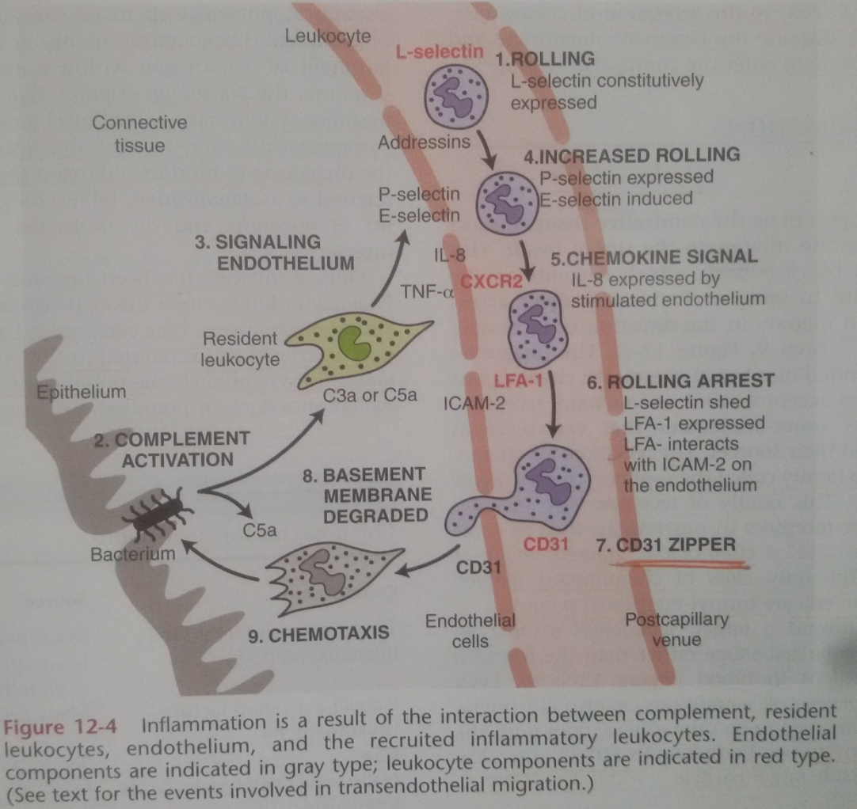

Chemotaxis and activation
- Chemotaxis is the directed movement of a cell along a chemical gradient.
- Chemotaxis depends on the leukocytes ability to sense a chemical gradient across its cell body and migrate in the direction of increasing concentration.
- The phagocyte senses only a limited number of chemicals – chemotaxins for which it has receptors.

Phagocytosis and degranulation
Phagocytosis consists of 3 distinct but interrelated steps-
- Recognition and attachment of the particle to the ingesting leukocyte.
- Engulfment, with subsequent formation of phagocyte vacuole.
- Killing and degradation of the ingested material.
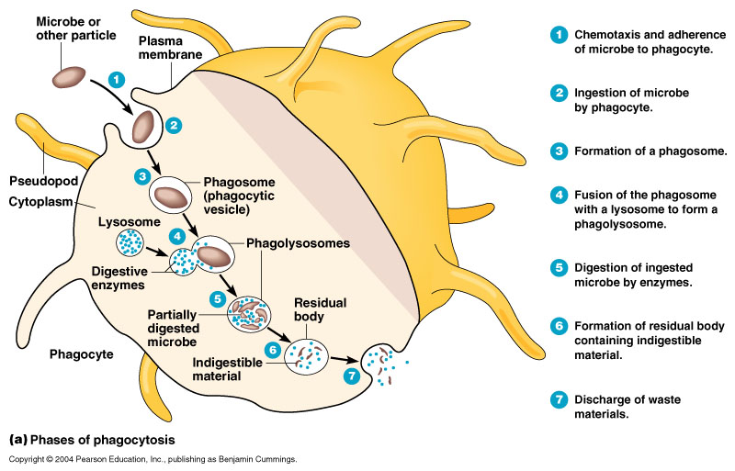
Killing or degradation stage
The anti microbial agents act by either of the following mechanisms.
- Oxygen – dependent bactericidal mechanism
- Oxygen – independent bactericidal mechanism
- Nitric oxide mechanism

- Oxygen – dependent bactericidal mechanism
By the production of reactive oxygen metabolites [O₂’, H₂O₂, OH’, HOCl, HOI, HOBr]
A phase of increased oxygen consumption ‘respiratory burst’, by activated leukocytes requires the essential presence of NaD PH oxidase.
2O₂
2O’₂
NADPH
oxidase
NADPH
NADP + H⁺

Superoxide is subsequently converted into H2O2 which has bactericidal properties :
2O₂’ + + 2H ⁺ H₂O₂ (Hydrogen Peroxide)

This type of bactericidal mechanism is
  - Via enzyme myeloperoxidase (MPO)
  - Independent of enzyme MPO.

a. MPO - dependent killing (H₂O₂ - MPO - Halide System)
MPO
H₂O₂ HOCI + H2O
Cl’, BR’, I’ Hypochlorous acid
    - MPO – independent killing.
OH’
O’₂
Haber-Weiss reaction
H₂O₂
Fenton reaction

Fe²⁺
OH’

- Oxygen independent bactericidal mechanism
Due to agents released from granules of phagocytic cells. These include lysosomal hydrolases, permeability increasing factors, defensins and cationic proteins.

- Nitric oxide mechanism
In experimental animals, NO has fungicidal and anti – parasitic action. Its role in bactericidal activity in human beings is yet not clear.

IMMUNOGLOBULINS
- These are glycoprotein molecule that are produced by plasma cells in response to an immunogen and which function as antibodies .
Immunoglobulins generally assume one of the two roles :
1] Plasma membrane bound antigen receptors on the surface of B cells
2] Free antibodies in cellular fluids functioning to intercept and eliminate antigenic determinants
Main function of immunoglobulins is to bind specifically to 1 or few closely related antigens . Each Ig actually binds to a specific antigenic determinants . Ag binding by antibody is the primary function of the Ab and can result in protection of the host .
- Basic structure of immunoglobulins –
Different Ig can differ structurally they all are built from the same basic units
A] Heavy and light chain :
- Have 4 chain structure
- 2 identical light chains – 23 KD
- 2 identical heavy chains – 50-70 KD
B] Disulfide bonds :
1] Inter chain disulfide bonds
2] Intra chain disulfide bonds
C] Variable [ V ] and constant [C ] region :
- Light chain – VL [ 110 A.A ] and CL [ 110 A.A ]
- Heavy chain – VH [ 110 A.A ] and CH [ 330 – 440 A.A ]
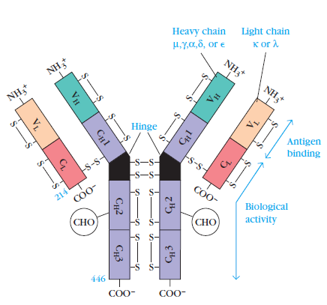

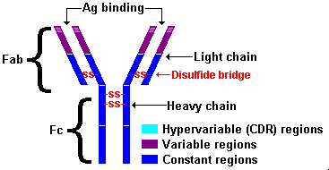

IMMUNE SYSTEM | HUMORAL COMPONENTS
Gingival | IgG/ IgA/ IgM
Serum | IgG/ IgA/ IgM
Saliva | SIgA/ IgG, mucins, defensins

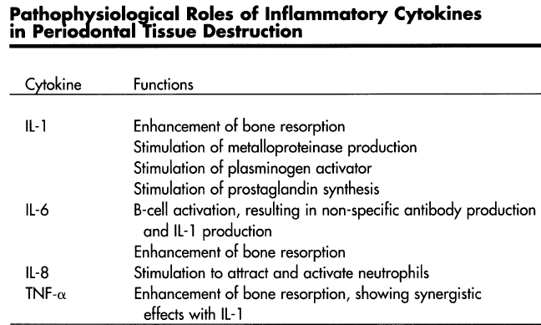

CONCLUSION
For understanding of the complex host responses in the etiology of periodontal diseases, one must have a thorough understanding of the basic concepts in immunology. The two major arms of immunity arm B-cell mediated humoral immunity and T-cell mediated cellular immunity. T -cells are major players in cell mediated immune response and also have a major role in humoral immune response. The humoral immunity is induced on contact of the antigen with the B-cells, which forms plasma cells, which in turn form antibodies. Antigens bind two antibodies at Fab fragment, while the phagocytes or complement components bind to the Fc fragment. The cellular immunity is induced by cytokines released by sensitized T lymphocytes. The immune mechanisms are usually protective, but may also result in host tissue damage by triggering several types of over reactions or hypersensitivities.

REFERENCES
- Clinical periodontology
Carranza & Newman
- Basic Pathology
Kumar , Cotrans , Robbins

