DEPARTMENT OF PROSTHODONTICS,
CROWN AND BRIDGE & ORAL IMPLANTOLOGY
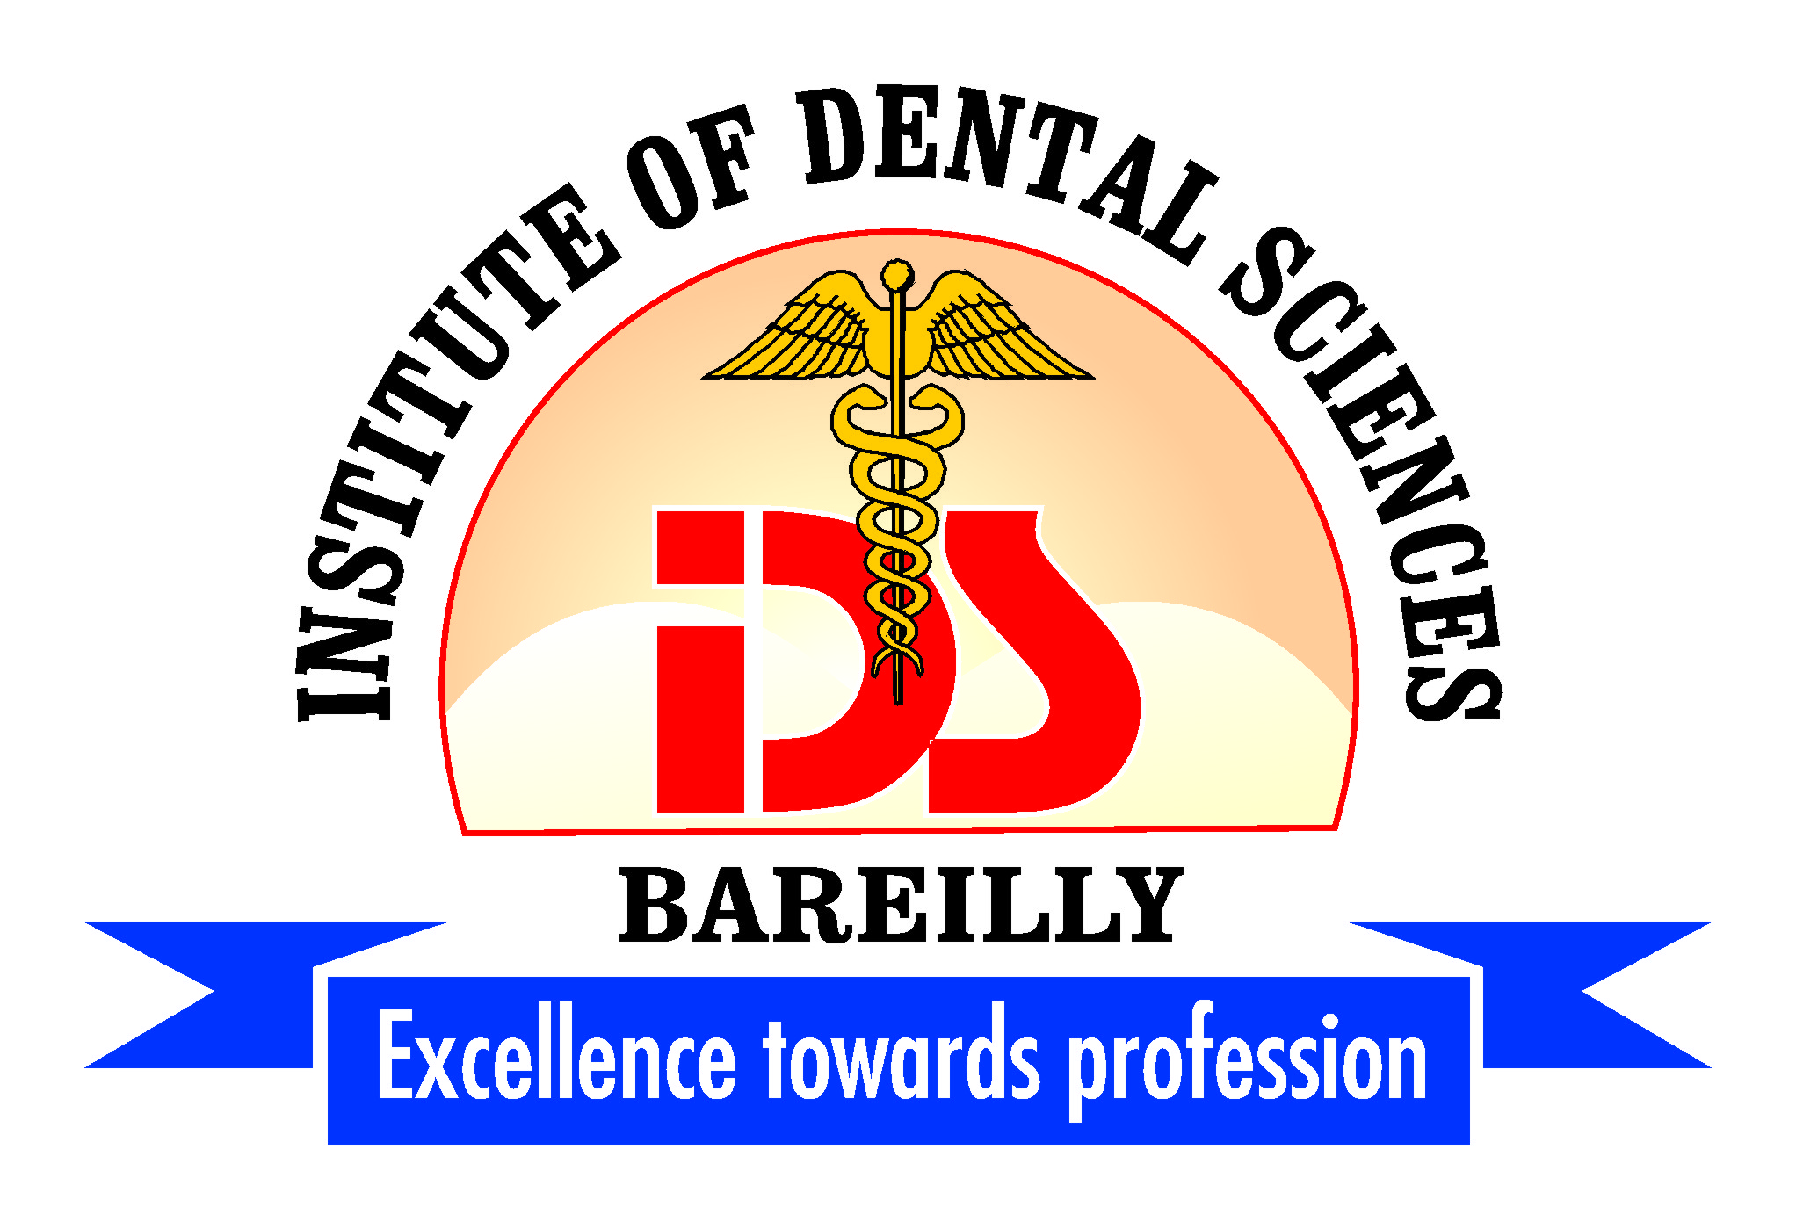

POSTGRADUATE
CLINICAL - LOG BOOK:
Removable Partial Denture
Batch MAY 2018 - 2021

POSTGRADUATE CLINICAL LOG BOOK

Name of the Department : PROSTHODONTICS, CROWN AND
BRIDGE & ORAL IMPLANTOLOGY

Name of Student : Dr. VAIBHAV BUDAKOTI

Postgraduate Degree : MASTER OF DENTAL SURGERY

Academic Year : 2018-2021

Name and Designation of Guide :

Signature of the Student :

CERTIFICATE

This is Certified that the content of this Clinical Logbook is the bonafide work of Dr. VAIBHAV BUDAKOTI a postgraduate student of Department of Prosthodontics, Crown and Bridge & Oral Implantology, Institute of Dental Sciences, Bareilly UP, for the academic year 2018 – 2021.

Signature, Name Signature, Name Signature, Name
And seal of Guide And seal of and seal of
Professor & HOD Principal
Date: Date: Date:
Place : Place: Place:

Deparment Of Prosthodontics, Institute Of Dental Sciences, Bareilly, UP.

History, Examination, Diagnosis And Treatment Planning: Removable Partially Edentulous Patient.
- Personal data:

Name ……………………… Age & Sex ……………………OPD No………………..
Occupation:……………………….. Phone No. …………………….
Address …………………………………………………………………………………
- Chief complaint:

- General Health and medical history: Good / Fair / Poor

- Mental status:

- Expectancy: Normar / High / Low

- Attitude: Normal / Nervous / Critical

- Intelligence: High / Average / Low
- Edentulous history
- Teeth lost due to: Periodontal Disease / Dental Caries / Trauma
- Period of semi-edentulous-ness: 1 to 6 month / 1 year / over 1 year
- Condition of previous denture: Satisfactory / Unsatisfactory
4. Why are dentures required: Esthetics / Speech / Mastication
- EXTRA ORAL EXAMINATION:
Esthetic opportunity: Favorable/Unfavorable/Not Applicable

Lip length and Support: Normal / Long / Short

T.M. Joints: Normal / Abnormal

Mouth Opening: ….. cm

- Intra Oral Examination:
Location of edentulous space : ………………… Anterior/ Posterior

Kennedy’s Classification: Class – I / Class – II / Class – III / Class– IV

Modification spaces:

- Condition of Edentulous areas
- Span - Normal / Reduced / Increased
- Vertical Space - Normal / Reduced

- Condition of Edentulous areas
- Form - Normal / Narrow / Resorbed / Undercut
- Mucosa - Normal / Thin / Flabby
- Sulcus depth - Normal / Reduced
- Tori (Palatinus / Mandibularis) Absent / Present

- Shape of palate:

- Condition of remaining teeth

- Pulp Calcification - Well calcified / Hypoplastic
- Presence of - Attrition / Abrasion / Erosion
- Dental Caries - Absent / Mid / Modearate / Severe
- Periodontal disease - Absent / Mid / Modearate / Severe
- Tooth position - Normal / Extrusion / Migration / Mobility
- Any other dental pathology - No evidence / Fractured teeth / Non vital teeth / Dis-coloured teeth
- Previous dental restorations - Nil / Restoration / Crown / Bridges
- Occlusion - Normal / Deranged
- Hypoplasia
- Discloration
- Extrusion
- Fracture
- Fixed bridge
- Crown
- Recession

- Cast Analysis – Diagnostic cast
- On articulator-
- Interridge space - Normal / Reduced
- Occlusal palne - Normal / Correctable / Doubtful correctability
- Interocclusal space - Adequate / Inadequate for occlusal rests
- Anomalies not observed - Absent / Present
clinically
- On surveyor: Diagnostic cast

- Most suitable abutment 1_______, 2_______, 3_______ 4_______, other _______

- Favorable retentive - Present / Absent
undercuts
- Opportunity to develop - Favourable / Unfavourable
guiding planes
- tooth alterations required - Yes / No

- Radiological Examination

- Ridges - Normal / Retained roots / Periapical pathology
- Abutment teeth
- Alveolar support - Very good / Good / Adequate
- Crown/ root ratio - Favourable / Unfavourable
- Vitality - Vital / Non Vital

- Any other investigation

- Prognosis: Good/Fair/Poor Good/Fair/Poor
1. support 2. stability
3. retention 4. Phonetics
5. Mastication 6. Esthetics
- Diagnosis:

Acrylic Partial Denture/ Cast Partial Denture/ Wrought Wire Partial Denture

- Treatment plan / mouth preparation for removable partial denture:
- Pre-prosthetic dental treatment
- Extractions ____________________________________
- Elimination of other oral pathology
- Pre-prosthetic surgery ________________________________
- Periodontal treatment ________________________________
- Restorations __________ Fillings / Crowns / Bridges _________________
- RCT and Full veneer crown:
- Occlusal Equilibration _________________________________
- Preparation of abutment teeth
- Elimination / Creation of undercuts __________________________________
- Creation of guiding planes _________________________________________
- Preparation of occlusal rest seats ___________________________________
- Duration of treatment …………………………………….
- Number of visits …………………………………

- Design for Acrylic Partial Denture:

Major Connector:

Minor Connector:

Rests
Direct Retainer

Indirect Retainer

Denture Base:

Teeth Replacement:

Patient Agreement:
I agree to above treatment.

Signature Of patients Date
TREATMET PROGRESS RECORD - REMOVABLE PARTIAL DENTURE

Patient’s Name………………………Age/Sex ……… OPD No. ………………………
Student’s Name ………………………, Roll Number ………………………
CLINICAL AND LAB PROCEDURES
Date | Steps | Remarks | Initials of Instructor
 | Case History & Examination
 | Primary Impressions – study model
 | Surveying of diagnostic cast
 | Tentative designing
 | Mouth Preparation
 | Selection & Modification of Trays
 | Final Impression
 | Final/ master cast
 | Surveying of master cast
 | Blockout of undercuts
 | Design transfer over master cast
 | Duplication of master cast
 | Bee Wax dip of refractory cast
 | Wax pattern on refractory cast
 | Investing and casting
 | Metal trial
 | Functional impression
 | Temporary base with occlusion rim
 | Vertical & Centric Jaw Relation
 | Arrangement of teeth
 | Try in
 | Waxing, carving, flasking, dewaxing, packing, curing, deflasking, finishing and polishing
 | Denture Insertion
 | Follow up

Received removable partial dentures Signature of Student

Signature of Patient Signature of Instructor

Date: Place:

Key Notes

Key Notes

Key Notes

