CONTENTS

- Neural crest development
- Formation of tooth
  - Bud stage
  - Cap stage
  - Bell stage
- Hard tissue formation
- Root formation
- Determination of crown pattern
- Dentin formation
- Enamel formation
- Cementum formation
- Formation of periodontal ligament
- Development of alveolar bone
- Development of gingival
- Epithelial mesenchymal interactions
- Conclusion

DEVELOPMENT OF TOOTH AND PERIODONTIUM

Development is the progressive evolution of a tissue and usually refers to an increase in its complexity and specialization. Development of the tooth involves many complex biologic processes including epithelial mesenchymal interactions, morphogenesis, fibrillogenesis and mineralization.

The primitive cavity is lined by a primitive 2 or 3-layered epithelium covering an embryonic connective tissue called ectomesenchyme, because of its origin from the neural crest.

Neural crest development
By about the 8th day of embryonic development cell differentiation has already occurred and 2 different cell types are present – ectoderm and endoderm. These two together form the BILAMINAR DISC. During the first three weeks there is rapid cell proliferation and migration and the bilaminar arrangement separates with the development of the mesoderm between the ectoderm and endoderm.
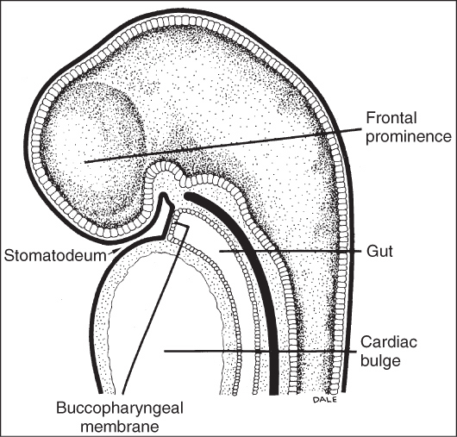

During the next few weeks the ectoderm thickens and forms the neural folds and ultimately the neural tube. As the neural crest develops, a group of cells differentiate from the lateral border of the neural crest called neural crest cells.
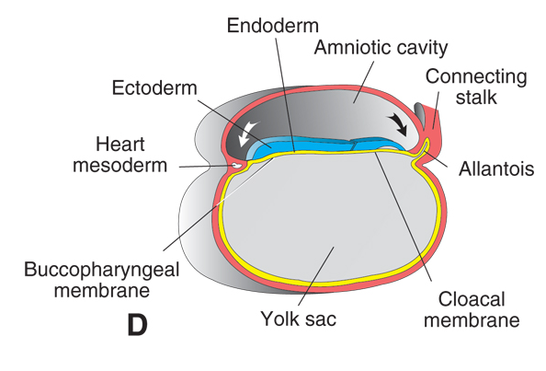

Most of the dental structure like dentin and cementum and their supporting tissues; periodontal ligament and bone develop from the neural crest cells. Enamel is produced from ectodermal cells.

After 37 days of development a continuous band of thickened epithelium forms around the mouth in the presumptive upper and lower jaws from the fusion of separate plates of thickened epithelium. These bands correspond in position to the future dental arches. This is called the PRIMARY EPITHELIAL BAND (PEB). The PEB gives rise to 2 subdivisions the vestibular lamina and the dental lamina.

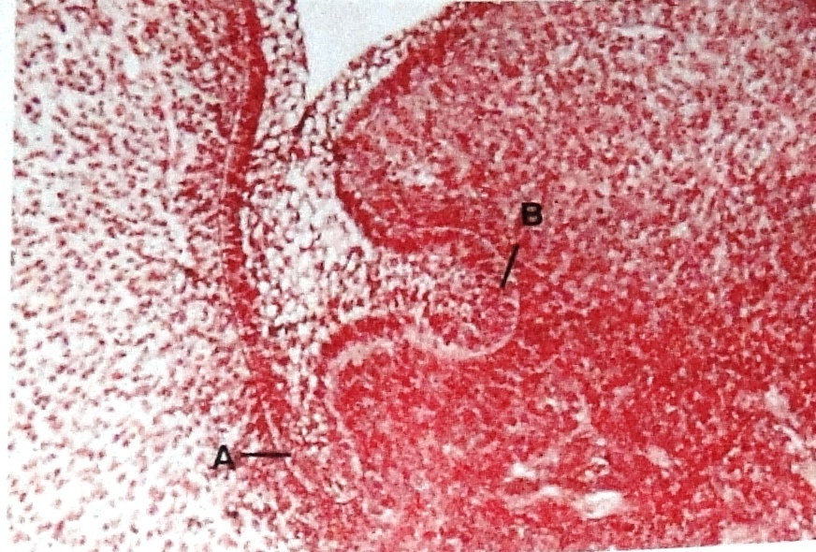

The vestibule forms as a result of the proliferation of the vestibular lamina into the ectomesencyme. Its cells rapidly enlarge and degenerate to form a cleft that becomes the vestibule between the cheek and tooth-bearing area.

During the 6th week of embryogenesis tooth development begins with a thickening of the oral epithelium lining the future dental arches to form the dental lamina. Within the dental lamina continued and localized proliferative activity leads to the formation of a series of epithelial ingrowths into the ectomesenchyme, at sites corresponding to the positions of the future deciduous teeth. At this time the MITOTIC INDEX LABELING INDEX and GROWTH OF EPITHELIAL CELLS are significantly lower than corresponding indices in the underlying ectomesenchyme which suggests that part of the ingrowth is achieved by ectomesenchymal upgrowth.
The initiation of this development appears to be directly by subepithelial ectomesenchyme that originates form the neural crest. The coordination of odontogenesis, morphogenesis and differentiations occurs through a serious of well-controlled inductive molecular interactions that have their origins in the ectoderm (enamel organ) and the ectomesenchyme (dental papilla and follicle).

The early series of events in tooth development are divided into three morphologic stages namely the Bud, Cap and Bell stage.

Bud stage
The stage of tooth development is the stage at which portions of the epithelium of the dental lamina begin to aggregate and form an invagination into underlying connective tissue.
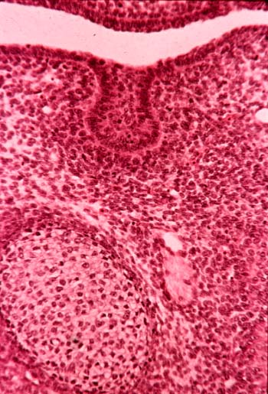

Cap stage (Proliferation)
The epithelial ingrowth which superficially resembles a cap sitting on a ball of condensed ectomesenchyme is called the dental/enamel organ. Epithelium continues to proliferate forming a cap like structure. Underneath this epithelial cap the mesenchymal cells begin to proliferate to form the dental papilla, which forms the dentin and pulp. The cells from the dental papilla continue to proliferate around the enamel organ to form the dental follicle from which cementum, periodontalligamnet and alveolar bone develop. The dental organ, papilla and follicle together constitute the TOOTH GERM.
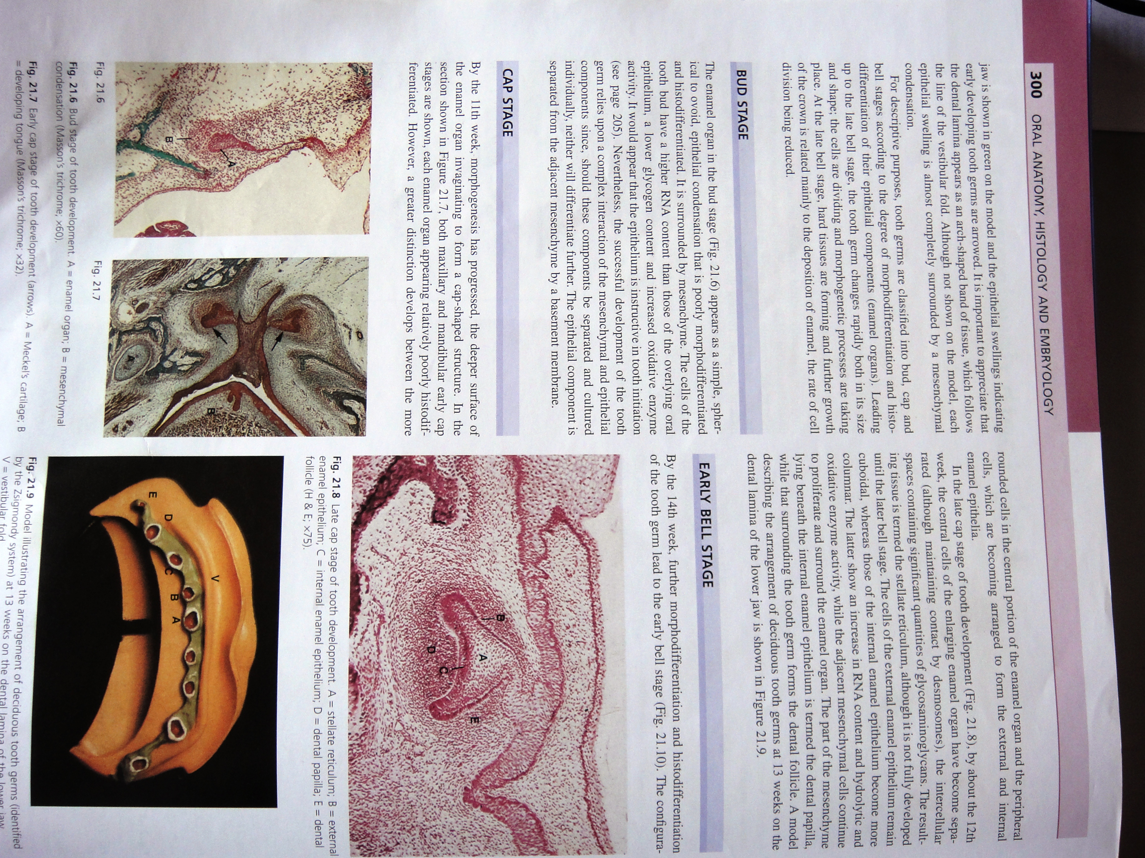
Bell stage (Histodifferntiation and Morpodifferentiation)
The enamel organ continues to proliferate to form a bell shaped structure. By this stage the enamel organ consists of four types of cells. As the tooth germ transitions from cap to bell stage important developmental changes occur. Through these changes called, histodifferentiation a mass of similar epithelial cells transform themselves into morphologically distinct components.

The cells in the centre of the dental organ continue to synthesize glycosaminoglycans and secrete them into the extracellular matrix between the epithelial cells. Glycosaminoglycans being hydrophilic pull water into the dental organ and the increasing amount of water pull the cells apart. But the cells still maintain connections with each other through their desmosomal contacts and become star shaped. Thus the center of the dental organ is termed the stellate reticulum.

At the periphery of the dental organ the cells assume a cuboid shape and form the external or outer enamel epithelium (EEE). The cells bordering on the dental papilla differentiate into histologically distinct components. Those immediately adjacent to papilla assume a short columnar shape and are characterized by high glycogen content. Together they form the internal or inner enamel epithelium.

Between the inner enamel epithelium (IEE) and the stellate reticulum the epithelial cells differentiate into a layer of flattened cells called stratum intermedium. The cells of this layer are characterized by an exceptionally high activity of the enzyme alkaline phosphatase.

Although cells of stratum intermedium and inner enamel epithelium are histologically different they should be considered as a single functional unit responsible for the formation of enamel. The inner and outer enamel epithelium meet at the rim of the dental organ and this junctional zone is called the cervical loop.

The important events take place in the dental lamina in the bell stage. The dental lamina joining the tooth germ to the oral epithelium breaks up into discrete islands of epithelial cells thus separating the developing tooth from the oral epithelium. The fragmentation of the dental lamina results in formation of discrete clusters of epithelial cells that normally degenerate and are resorbed. If any persist they may form small cysts called eruption cysts over the developing tooth and delay eruption. Second the inner enamel epithelium folds making it possible to recognize the shape of the further crown pattern of the tooth.
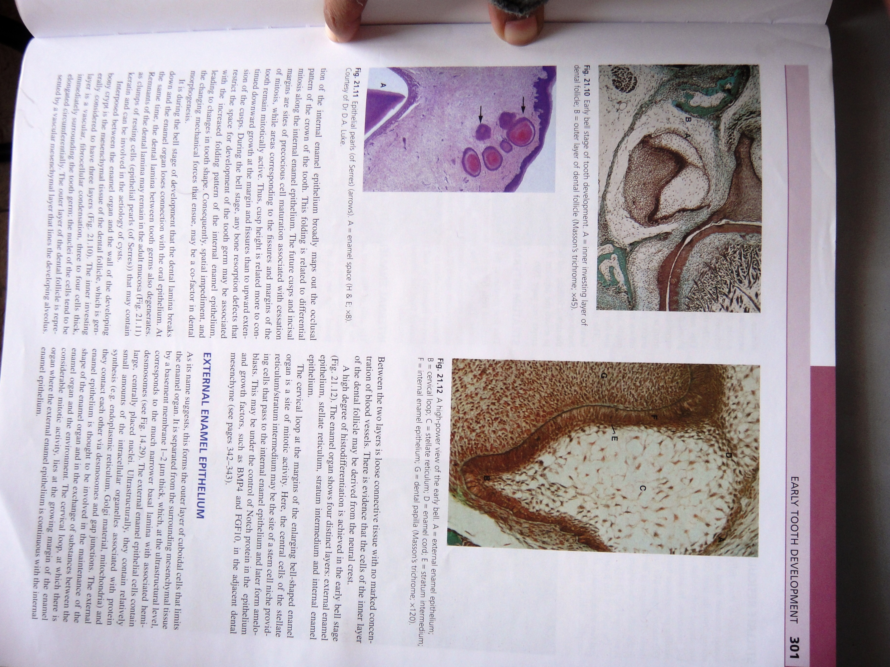

Formation of the permanent dentition
The permanent or secondary dentition also arises from the dental lamina. The tooth germs that will give rise to the permanent incisors, canines and premolars form as a result of proliferative activity within the dental lamina at a point where it joins the dental organs of the deciduous tooth germs. This increased proliferative activity leads to the formation of another epithelial cap and associated ectomesenchymal response on the lingual aspect of the deciduous tooth germ. The molars of the permanent dentition have no deciduous predecessors and so do not originate in the same way. Instead when the jaws grow long enough the dental lamina burrows backward beneath the lining epithelium of the oral mucosa into the ectomesenchyme. This backward extension of the dental lamina successively gives off epithelial ingrowths which together with associated ecotomesenchal response gives rise to the first, second and third molars.

Thus the primary and secondary dentin forms in essentially the same way although at different times. The entire primary dentition is initiated between the sixth and eighth week of embryonic development and the successional permanent teeth between twentieth week in utero and the tenth month after birth. The permanent molars between the twentieth week in utero for the first molar and the fifth year of life for the third molar.

Hard tissue formation or crown stage
Late in the bell stage of tooth development the two principal hard tissues of the tooth, the dentin and enamel are formed. Formation of dentin always precedes enamel formation and marks the onset of the crown stage of tooth development.
Until the completion of the bell stage, the cells of the inner enamel epithelium are continually dividing to permit overall growth of the tooth germ. At the sites of the future cusp tips where dentin will be first formed, mitotic activity ceases and the small columnar cells of the inner enamel epithelium elongate and become tall and columnar in shape with their nuclei aligned adjacent to the stratum intermedium and away form the dental papilla. Changes also occur in the adjacent dental papilla. The undifferentiated ectomesenchymal cells of the dental papilla increase in size and differentiate into odontoblasts. This differentiation of the odontoblasts from the undifferentiated cells of the ectomesenchyme is initiated by an organizing influence from the elongated cells of the inner enamel epithelium. In the absence of epithelium no dentin will form.

As development continues there is progressive maturation of the cells of the inner enamel epithelium down the cusp slopes and a progressive differentiation of odontoblasts in the papilla.

The odontoblasts as they differentiate begin to elaborate organic matrix of dentin, collagen and ground substance, which is ultimately mineralized. As the organic matrix is deposited the odontoblasts move towards the center of the dental papilla leaving behind a cytoplasmic extension around which dentin is formed. This results in the tubular nature of dentin.

After this first dentin has formed, the cells of the inner enamel epithelium differentiate and assume a secretory function producing an organic matrix against the newly formed dentin surface. This organic matrix is mineralized almost immediately to form enamel.

It has been stated the odontoblasts differentiate under an organizing influence stemming from the cells of the inner enamel epithelium. Likewise it has been stressed that enamel formation cannot begin until some dentin has been formed. This interdependence between the two tissues is an example of RECIPROCAL INDUCTION.

Before the formation of the first dentin the nutrition of the dental organ in particular the cells of the IEE comes from the sources; blood vessels located in the dental papilla and those situated along the periphery of the EEE. When dentin is formed it cuts off the papillary source of nutrients. This reduction in nutrients occurs at a time when the cells of the IEE are about to secrete enamel and thus there is an increased demand for nutrients. This demand is satisfied by a collapse of the stellate reticulum and so the ameloblasts are approximated to the blood vessels lying outside the EEE. Until this point the ameloblasts meet their metabolic requirements by using the glycogen stored in their cytoplasm and also by using some of the extracellular components of the stellate reticulum.

Root formation
Just as in crown formation, epithelial cells are required for initiation of the odontoblasts that will eventually form the root dentin. Odontoblasts are formed as epithelial cells of the IEE and EEE proliferate from the cervical loop of the dental organ to form a double layer of cells called the Hertwigs epithelial root sheath. This sheath grows around the dental papilla between the papilla and the follicle until it encloses all, but the basal portion of the papilla. The rim of this root sheath encloses the primary apical foramen. As the cells of the IEE progressively enclose more and more of the expanding dental papilla they initiate the differentiation of odontoblasts from the cells at the periphery of the dental papilla.

Multirooted teeth are formed in essentially the same way. Only you have to visualize two tongues of epithelium growing towards each other to enclose two primary apical foramina. If three tongues are formed three apical foramina are formed.

The root sheath once it forms rapidly initiates root formation and fragments. The tip of the forming root remains in a stationary position relative to the inferior border of the mandible, which means that the free border of the root sheath must be in a stable position. With the onset of root formation the crown of the root is growing away from the bony base of the crypt and the root sheath is not actually growing into the jaw. Because of these growth changes the root sheath is stretched and eventually fragments to form a fenestrated network around the tooth. In longitudinal sections this fenestrated network around the tooth. In longitudinal sections this fenestrated network is seen as a discrete cluster of epithelial cells known as the epithelial cells rests of Malassez. In the adult these cell rests persist next to the root surface in the periodontal ligament. They are functionless but are the source of the epithelial lining of the dental cysts that develop in reaction to inflammation of the periodontal ligament.

Mechanism of crown pattern determination
Crown pattern of the tooth is determined during the bell stage of tooth development. At this stage the stellate reticulum cells are separated from each other by ground substance consisting largely of mucopolysaccharides which attract water so the dental organ is turgid and exerts pressure on both the IEE and EEE. The growing dental papilla also exerts pressure on the IEE since it is contained within the dental follicle. The epithelium is therefore in a state of equilibrium between two opposing forces that cancel each other. The folding that occurs as the crown pattern develops is caused by differential rates of mitotic activity.

When the tooth germ is growing rapidly in the early bell stage, cell division occurs throughout the IEE. As development continues, cell division ceases at a particular point in the IEE as the cells begin to differentiate and assume their eventual function of producing enamel. The point where maturation of the cells of the IEE first occurs represents the site of future cusp development. Since the IEE is constrained at the cervical loop and because there is continued proliferation of the cells on each side of the zone of maturation the epithelium buckles and forms a cuspal outline. Thus the future cusp is pushed upwards towards the EEE. The zone of maturation eventually sweeps down the cusp slopes and is followed by dentin and enamel formation. The occurrence of a second zone of maturation within the IEE leads to the formation of a second cusp and so on until the final cuspal pattern of the crown is determined.

Some researchers believe that the factors causing maturation and cessation of cell division in the IEE reside in the ectomesenchyme of the dental papilla. Thus it is clear that the shape of the crown results from interaction between the dental papilla, ectomesenchyme and the IEE.

Determination of tooth shape also depends on such interactions. Humans being heterodonts the teeth fall into three groups – incisiform, caniniform and molariform.

There are two theories that try to explain the initiation of teeth of different families. The question asked is do the neural crest cells as they migrate and form ectomesenchyme become programmed to form teeth all of one family that subsequently become modified in shape by local external factors – FIELD THEORY; or is the tooth-forming ectomesenchyme initially differentiated to form teeth of different families.

The field theory proposes three separate graded fields in the jaw for the three families of teeth. Thus a tooth bud forming at a given location develops according to its location within the field. The CLONE THEORY states that the ectomesenchyme as it migrates into the jaws becomes segregated into three clones: incisor, canine and molar. There is some experimental evidence to support both claims.

Dentin formation
The differentiation of odontoblasts from the dental papilla requires the presence of epithelial cells or their products. This inductive role of epithelium has been recognized for many years and hence any description of dentin formation should always begin with histologic changes that occur within the IEE. Apart from this inductive influence dentin formation is purely a connective tissue event.

Before dentinogenesis begins the cells of the IEE are short and columnar in shape and are rapidly dividing to accommodate the growing tooth germ. The cells are supported by a basement membrane that supports the epithelium fro the dental papilla.

The cells of the dental papilla at this time are separated from the IEE by an acellular zone and are small undifferentiated ectomesenchymal cells with a central nucleus and sparse cytoplasm containing few cytoplasmic organelles.

Cell division stops in the cells of the IEE and their shape changes to tall columnar and the nucleus migrates to the pole away from the dental papilla. Immediately after this, the cells of the dental papilla rapidly enlarge as their cytoplasm increases in volume to contain increasing amounts of rough endoplasmic reticulum and golgi complexes. They are highly polarized with nuclei positioned away from the IEE. The acellular zone between the dental papilla and the IEE is eliminated as the odontoblasts differentiate and increase in size to occupy this zone.

Some studies have shown that ectomesenchymal cells must undergo a number of cell divisions before they develop the capacity to respond to an epithelial influence and differentiate into odontoblasts. During the final division of the ectomesenchymal cells adjacent to the IEE the mitotic spindles are perpendicular to the basement membrane supporting the IEE and hence only the daughter cells next to the basement membrane differentiate into odontoblasts. As a result, two populations of cells can be differentiated – odontoblasts and subodontoblasts.

After the differentiation of the secretory odontoblasts, mantle dentin is formed containing type I collagen of large diameter. There large collagen fibrils along with the ground substance constitute the first formed or mantle dentin.

During the secretion of mantle dentin the cells increase in size and the extracellular compartment is obliterated. The odontoblasts move away from the IEE towards the pulp leaving behind an odontoblastic process. The plasma membranes of the odontoblasts adjacent to the IEE push out short stubby processes which on occasion penetrate the basal lamina and interpose between the cells of the IEE. These are called enamel spindles. Also small membrane bound vesicles are formed between the collagen fibrils called matrix vesicles. Hydroxyl apatite is first formed within the matrix vesicles as single clusters. These crystals grow rapidly and rupture from the confines of the vesicle, which fuse with adjacent crystals to form a fully mineralized matrix. Deposition of mineral always lags behind the formation of organic matrix and hence there is always a layer of organic matrix called predentin found between the odontoblasts and the mineralized front.

After the formation of mantel dentin, primary or physiologic dentin is formed. The collagen in primary dentin is in smaller fibrils, which are more closely packed and interwoven. Matrix vesicles are no longer secreted by the odontoblasts and mineralization is by heterogenous nucleation, secondary nucleation and crystal growth. Odontoblasts secrete lipids, phophoproteins. Evidence shows that these lipids are involved in mineralization of primary dentin.

Mineralization of dentin occurs by globular or calcospheric calcification which involves the deposition of crystals in several discrete areas of matrix at any one time. With continues crystal growth these crystals form globular masses, which eventually fuse to form a single calcified mass. On occasion these large globular masses fail to fuse and leave small uncalcified areas known as interglobular dentin. In the rest of the circumpulpal dentin the size of the globules progressively decreases until the mineralization front appears linear. The size of the globules seems to depend on the rate of dentin deposition, with larger globules occurring where dentin deposition is fastest.

In summary dentinogenesis result in the production of an organic matrix calcified with apatite crystals through which run cytoplasmic extensions of the odontoblasts occupying dentinal tubules. Coronal dentin deposition occurs at a rate of about 4 micron meter per day in an incremental manner.

Root dentin formation differs only very slightly from coronal dentin formation in that the rate of deposition is slower and the orientation of the collagen fibers is different. The differentiation of odontoblasts that form root dentin is initiated by the epithelial cells of the Hertwigs root sheath.
Secondary dentin formation is achieved essentially the same way as primary dentin although the rate of formation is slower. Secondary dentin stains less well for glysoaminoglycans and also is less mineralized.

Tertiary or reparative dentin is deposited at specific sites in response to injury. The rate of its deposition depends on the degree of injury; the more severe the injury, the more rapid the rate of dentin deposition with as much as 3.5 microns being deposited in a single day. As a result of this rapid rate of deposition, odontoblasts often become trapped in the newly formed matrix.

Enamel formation
Enamel is ectodermally derived tissue covering the anatomic crown of the tooth. It is formed by the enamel organ, which is derived from a localized proliferation of the oral epithelium. The ameloblasts are derived from the IEE of the enamel organ. This process of differentiation requires presence of dentin it begins at the future cusp tip and follows the developing dentin down the slopes of the cusp.

In dentinogenesis, the odontoblasts retreat centrally leaving behind formed dentin. The ameloblasts also retreat but in a peripheral direction leaving newly formed enamel over dentin. The IEE terminates at the cervical loop and this determines the extent of enamel deposition. Enamel differs form other hard tissues, which are all derived from connective tissue, in that it is an ectodermal product, and it has a unique matrix and a distinctive pattern of mineralization.

Enamel formation comprises of 2 stages: secretion and mineralization. The first stage is formative and involves the secretion of at an average rate of 0.023mm per day of an organic matrix, that is almost immediately partially mineralized. Secretion and partial mineralization continue until almost all of the entire thickness of enamel has been formed. The organic matrixes when first secreted have two types of proteins – amelogenins and enamelins. Amelogenins exceed enamelins by a ratio of 19:1. During this phase the enamel gets mineralized up to 30% and retains a soft consistency.

Enamel then undergoes a maturation process where the apatite crystals continue to grow and the protein and water content goes down. Maturation begins at the DENTINOENAMEL JUNCTION (DEJ) at about the same time the enamel secretion has reached its complete thickness. It starts at the DEJ and takes place at a rate twice as fast as matrix secretion.

The IEE and stratum intermedium which is rich in alkaline phosphatase should be considered together during enamel formation. In the cervical loop region the IEE cells are short and columnar and as we move coronally they become tall and columnar and their nuclei are aligned to the proximal end of the cells adjacent to the stratum intermedium. The acellular zone of the dental papilla seems to disappear as dentin formation has begun. After dentin secretion has begun the cells of the IEE now called ameloblasts begin to secrete the enamel matrix, which is immediately partially mineralized. As this first increment of enamel is formed the ameloblasts begin to move away from the dentin surface and soon each cell forms a short conical projection called Tomes processes that jut into the newly forming enamel, giving the junction between the enamel and the ameloblasts a picket fence like appearance.

During this time the enamel organ collapses. The volume of the stellate reticulum is reduced by loss of intercellular substance. This brings the blood vessels in the follicle close to the ameloblasts as they lose their nutrient supply from the papilla due to formation of dentin.

As enamel formation continues, the cells of the EEE, stratum intermedium and stellate reticulum lose their discrete identities and form a stratified layer of epithelium adjacent to the ameloblasts, which have now become short and have lost their tomes processes join together with the adjacent stratified epithelium to form the REE.

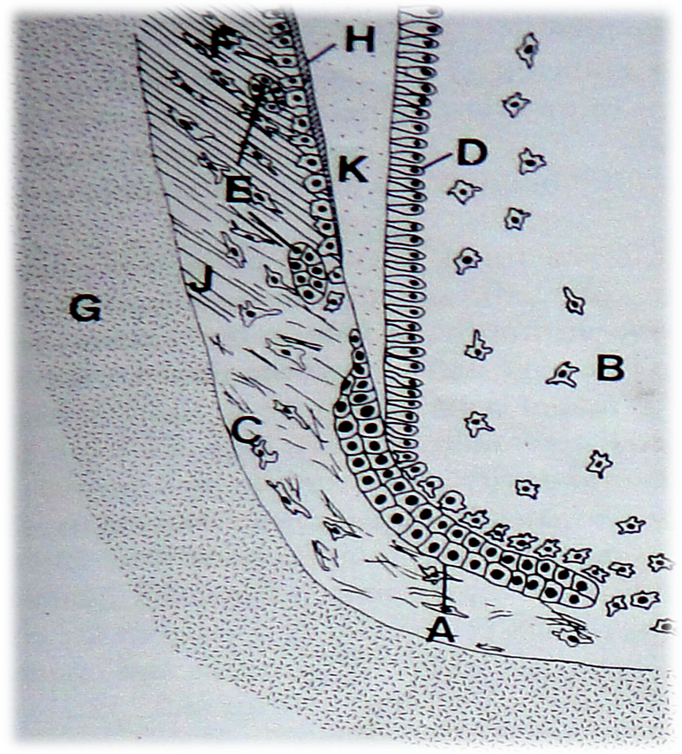
A= ERS; B=dental papilla; C=dental follicle; D=odontoblasts; E=epithelial rests; F=cementoblasts; G=developing alveolar bone; H=developing cementum; J=developing periodontal ligament; K=root dentine

Cementum development
Cementum is deposited on the surface of root dentin. Once root dentin formation has begun the continuous root sheath fragments and forms network that enables follicular cells to pass between the cells of the root sheath and to come into apposition with the newly formed root surface. Here the follicular cells now known as cementoblasts differentiate and begin to deposit the organic matrix of cementum, consisting of intrinsic collagen fibres and ground substance against the root surface and around the forming ligament fiber bundles or extrinsic fibers.

Mineralization of this cementoid occurs in a similar manner to dentin by the formation of apatite crystals within the matrix vesicles. The cementum is laid down slowly as the tooth is erupting and the cells retreat in to the periodontal ligament and so this cementum is acellular. Once the tooth is in occlusion more cementum forms usually around the apical two thirds of the root, which has a greater proportion of collagen and the cementoblasts become trapped in lacunae within this matrix so that the cementum is cellular.
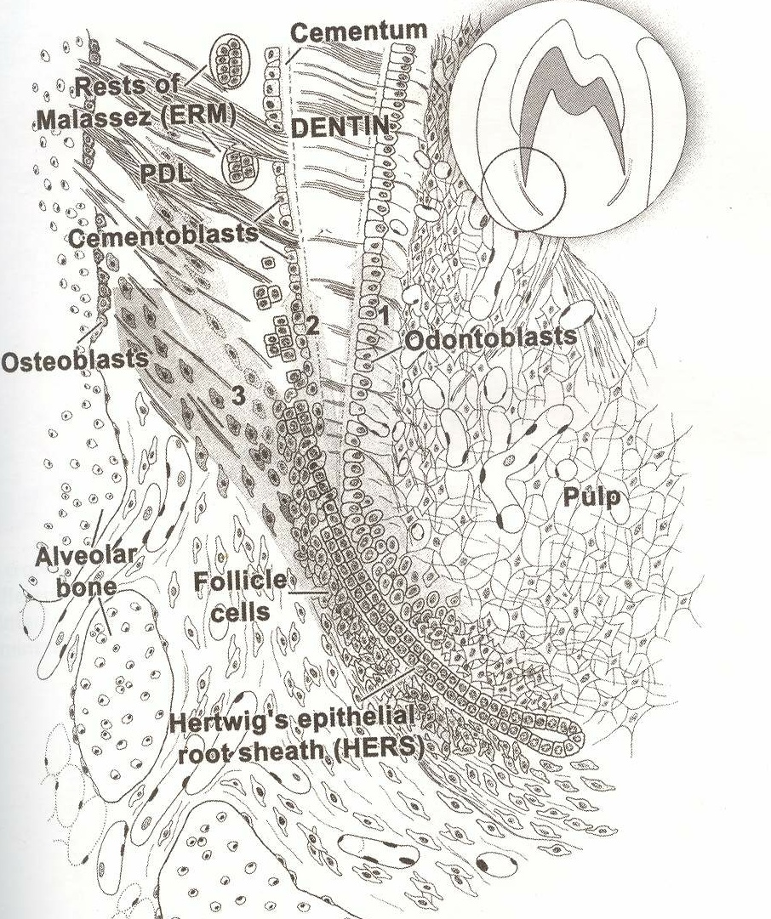

Enamel matrix proteins such as amelogenins, enamellins and tuftelins seem to play an important role in cementogenesis. They seem to help in the differentiation of cementoblasts from the dental follicle. The commercially available form of these enamel matrix proteins, which has a porcine source, is called EMDOGAIN, which is being used, increasingly in periodontal regenerative procedures.

Periodontal ligament development
The periodontal ligament spans the space between the root surface and the alveolar bone. It is a fibrous connective tissue that arises from the fibroblasts that differentiate from the undifferentiated cells of the dental follicle. The first formed fibres are parallel to the root surface. These fibres later become the dentogingival and transseptal fibres. The periodontal ligament forms shortly after root formation begins. The ligament develops from the dental follicle. Before the tooth erupts the crest of the alveolar bone is above the CEJ and the developing fiber bundles of the ligament are all directed obliquely. As the tooth moves during eruption the alveolar crest comes to coincide with the CEJ and the oblique fibres below the free gingival fibres become horizontal.

When the tooth finally comes into occlusion the alveolar crest is positioned near the apex and the fibers become oblique again with the cemental attachment being coronal to the apical attachment. The principal fibres of the periodontal ligament come into their final position only after tooth eruption is complete.

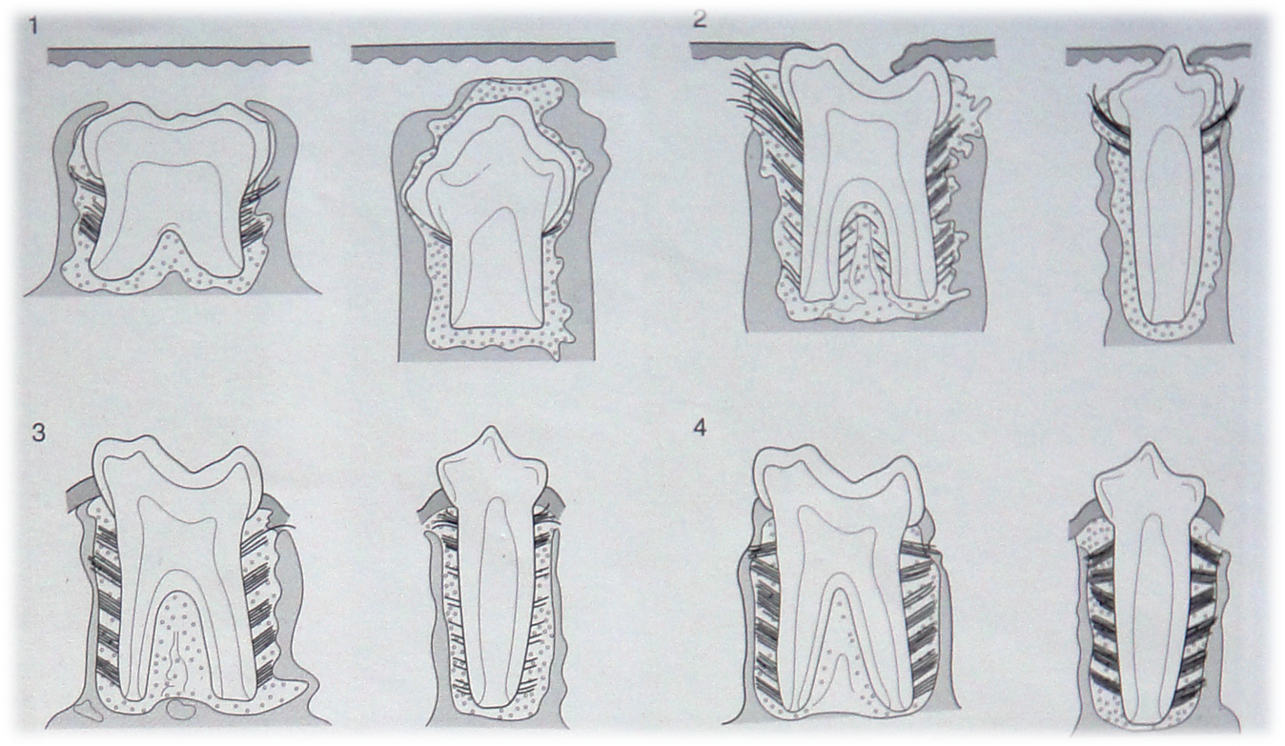
Alveolar bone development
Teeth are located within the bony sockets in the alveolar processes of the maxilla and mandible. The thin lamella of bone that lines the socket wall and contains inserting Sharpeys fibers is known as the alveolar bone. The alveolar bone is formed during root development and is derived from cells originating in the dental follicle. Its development is independent of other portions of the alveolar process and in intimately associated with the presence and development of teeth and the subsequent development of the periodontal attachment apparatus.

Primary teeth and permanent teeth that do not have any precursor tooth develop alveolar bone around their roots during development and subsequent eruption. Initially the succedaneous teeth are located within the same osseous cavity as their deciduous precursors. However as the deciduous teeth erupt, alveolar bone is deposited around the developing roots and serves to separate the erupting deciduous tooth from the underlying developing succedaneous tooth crown. Only when the permanent tooth erupts into the oral cavity, is new alveolar bone deposited around the tooth and the alveolar process assumes its final form.

Development of gingiva
Before the tooth begins to erupt the crown of the tooth is covered by a double layer of epithelial cells. Those in contact with enamel are the post secretory ameloblasts that develop hemidesmosomes and attach themselves to a basal lamina and become firmly attached to the enamel surface.

The outer layer consists of more flattened cells which are the remnants of all the remaining layers of the dental organ. These two layers of cells are called the reduced enamel epithelium. Between the REE and the overlying oral epithelium is the connective tissue. When tooth eruption begins this connective tissue breaks down. In response to hits break down of connective tissue, the epithelium responds in the characteristic manner in which epithelium supported by damaged connective tissue responds. A widening of the intercellular spaces between the epithelial cells occurs as they proliferate and migrate. As a result the cells of the outer layer of the REE and the basal cells of the oral epithelium proliferate and migrate into the degenerating connective tissue and eventually fuse to form a mass of epithelial cells over the erupting tooth. This leads to the formation of an epithelium-lined canal through which the tooth erupts without hemorrhage.

Once the tip of the cusp has erupted into the oral cavity, oral epithelial cells begin to migrate partially over the REE in an apical direction. The attachment of the gingival epithelium to tooth is maintained through the reduced ameloblasts and their hemidesmosomes and basal lamina adjacent to the enamel surface. This is the primary epithelial attachment. This eventually forms the junctional epithelium.

Gradually the reduced ameloblasts change their morphology and are transformed into squamous epithelial cells that retain their attachment to the enamel surface. The cells of the outer layer of the REE also change into squamous epithelial cells but retain their ability to divide. Due to this continuous cell division, the ameoloblasts are eventually replaced by the daughter cells of the REE. As the epithelial cells of the cuff stratify they further separate the cells of the transformed dental epithelium from the nutritive supply with the consequence that these latter cells degenerate and create a gingival sulcus.

After the development of the gingiva and dentogingival unit is complete the dentogingival junction extends to the CEJ and its epithelial component consists of junctional epithelium formed by transformation of REE and sulcular epithelium derived from the epithelial cuff.

The epithelium thus has many important roles in tooth formation. The main ones being
- Morphogenetic function that helps to determine crown pattern of the tooth.
- Inductive role in initiating coronal and root dentin formation and hence determines the size, shape and number of roots of a tooth.
- It has a formative function in that its cells secrete enamel.
- It permits tooth eruption without the exposure of connective tissue.
- It assists in establishing the dentogingival junction.

Epithelial-Mesenchymal interactions
During embryonic development of all orans an intricate and functional relationship exists between the epithelial and mesenchymal tissues. The studies of Spemann as early as 1938 showed that the presence of this type of communication was essential for organogenesis. Odontogenesis has proved to be an excellent model for studying these interactions since epithelial mesenchymal interactions occur at all stages of tooth development. Once the enamel organ has formed during tooth development the cells of the IEE appear to induce the adjacent cells in the dental papilla to differentiate into odontoblasts. However enamel formation by ameloblasts cannot proceed until odontoblasts have begun to secrete dentin. Such an interaction between the two tissues in known as RECIPROCAL INDUCTION. Signaling molecules are required for these interactions to proceed. The important signaling molecules are transcription factors and growth factors.

Transcription factors are involved in gene expression. The important transcription factors are the Homeobox genes and the Dlx-1 and Dlx-2 genes. These transcription factors are involved in specifying the spatial location of future tooth germs. Following gene expression cell differentiation and organ development continue to be controlled by locally produced molecules such as growth factors.

Growth factors are soluble polypeptides secreted by cells that act within the local environment either in a paracrine or autocrine function. They exert their influence on cells via cell surface receptors. During odontogenesis, the BMP’s, TGF-β and FGF have been found to be expressed differentially according to the stage of development, morphogenesis and cell differentiation. Other growth factors including PDGF and EGF have also been associated with different stages of tooth development.

Reciprocal relationships between epithelium and its sustaining connective tissue are involved in many aspects of dental development and include
- Initiation of tooth formation
- Determination of tooth’s crown pattern
- Initiation of dentinogenesis
- Initiation of amelogenesis
- Determination of size, shape and number of tooth roots
- The determination of the anatomy of the dentogingival unit

Conclusion
Tooth development is a very complex yet well defined series of events driven by molecular processes that are still in the early stages of research and study.

Knowledge about the development of these tissues is important since it will help us understand better the mechanisms required for inducing repair and regeneration of damaged tissues.

REFERENCES

- Janlindhe: Clinical periodontology and Implant dentistry
- Orbans: Oral histology and Embrology cementum mosby
- Tencates, Antonio Nanai: Oral histology Development, Structure and Junction.
- Carranza: Clinical periodontology tooth supporting structures, Savunders , 2003 (Pg: 42-45)
- Berkowitz BKB, Holland GR and Moxham BJ. Oral anatomy, embryology and histology
- Neville, Damn, Allen and Bouquot. Oral and maxillofacial pathology – 2nd ed, 2002
- Shafer, Hine and Levy. Shafer’s textbook of oral pathology.

