INSTITUTE OF DENTAL SCIENCES, BAREILLY
DEPT. OF PROSTHODONTICS AND CROWN & BRIDGE

CASE HISTORY PROFORMA – IMPLANT SUPPORTED PROSTHESIS FOR PARTIALLY EDENTULOUS

- Patient Data:

Name: OPD No: Date:

Age: Sex: Occupation: Marital Status:

Address: ________________________________________________

Contact No: ________________

- Chief complaint & History of presenting illness:

Chief complaint:

Treatment need:

- Medical History:
General health:

Pathology/Systemic diseases:
Diabetes / Thyroid / other Endocrinal diseases: _________________
Epilepsy / other CNS diseases: _______________________
Hypertension/ other CVS diseases: ___________________
Tuberculosis / AIDS / Hepatitis / other Infectious diseases:__________________
Asthma / other Respiratory diseases: ____________________________
Arthritis / other Bone & Joint diseases: ________________________
Kidney dysfunction / other Genito-urinary diseases: ______________________
Anaemia / Bleeding disorders / other Haematopoietic diseases:______________
Jaundice / other GIT diseases: _______________________
Medication (Present history):
Mouth dryness: _____________________________
Allergy: ___________________________________
Menopause: _______________________________
Pregnancy: ________________________________
Neoplasm: _________________________________
Radiation: __________________________________
Hospitalization: _______________________________
Anesthesia: __________________________________

- Personal History:

Diet history:

Diet habits:Veg / Non-Veg

Any Habits: Pan / Tobacco chewing / Smoking / Alcohol / Recreational drugs / Others

Any Abrasive or Erosive Diet Habits: Citrus foods / Fruit juices / Carbonated

drinks / Pickles / Vinegar

Parafunctional habits:

Type: Bruxism / Pen biting / Pipe smoking / Holding objects between teeth

Frequency: __________________Duration: _______________________

Oral Hygiene:

Type of tooth brush: Soft/Medium/Hard

Frequency & Time of tooth brushing: _____________________

- Socio-psychologic History:

Family Status: _________________________

Educational Status: _______________________

Personality: Philosophical/ Exacting /Hysterical/ Indifferent

- Dental History:

Extraction history: | Reason (Periodontal / Caries / Other) | Year
Maxillary anterior
Maxillary left posterior
Maxillary right posterior
Mandibular anterior
Mandibular left posterior
Mandibular right posterior | __________ | _

Age of present prostheses: ____________________

Duration of missing teeth/immediate: Maxillary: __________Mandibular: ___________

Number and type of previous prostheses:

Removable partial denture: Maxillary: _____________ Mandibular: _________

Fixed partial denture: Maxillary: ____________ Mandibular: ____________

Earlier denture experience: satisfactory / unsatisfactory

Expectations: Mastication / Speech / Appearance / Comfort / Professional

Pre-extraction records: Casts / Measurements / Photographs / Old dentures

- Clinical examination:

- EXTRAORAL EXAMINATION: Physical characteristics-

Cosmetic index: 1 - High cosmetic index/ 2- Mid cosmetic index/ 3- Low Cosmetic index

Personality: Delicate / Average / Vigorous

Facial expression: Tense / Average / Pleasing

Complexion: Skin color: ___________ Skin texture: ___________

Neuromuscular evaluation:

Coordination: Class 1–Excellent/ Class 2–Fair/ Class 3–Poor

Speech: Normal / Affected

Facial form:

Front: Square/ Tapering/ Square-tapering/ Ovoid

Profile:

Class 1–Normal / Class 2–Retrognathic / Class 3–Prognathic

Height: Normal / Decreased / Increased

Symmetry: Symmetrical / Asymmetrical

Lip: Thin / Full / Tense / Active

Lip contour: Adequately supported / unsupported

Maxillary:________ Mandibular: __________

Mobility: Class 1–normal/ Class 2–reduced mobility/ Class 3–paralysis

Length: Long/Medium/Short

Smile line: Incisal 1-3rd/ Middle 1-3rd/ Cervical 1-3rd/ Gummy Smile

TMJ:
Comfort/Crepitus/Clicking/Smoothness/Locking:
Deviation: _____mm
Protrusive: Limited / Unlimited
Left Lateral: Limited / Unlimited
Right Lateral: Limited / Unlimited
Mouth opening: ______mm

Lymph node: Palpable / Not palpable

- INTRAORAL EXAMINATION:

Partially Edenulous:

- Implant site:

Partial Edentulous space area no.

Bone character: type1/type2/type3/type4

Recent extraction: __________________

Attached gingiva: Favourable–3 mm / Adequate–1–2 mm / Unfavourable–None

Interarch space: Favourable / Adequate / Unfavourable

Tissue support area: Favourable / Adequate / Unfavourable

Soft and Hard tissue anatomy:

  - Deficiencies: b. Limitations:

- Existing Dentition:

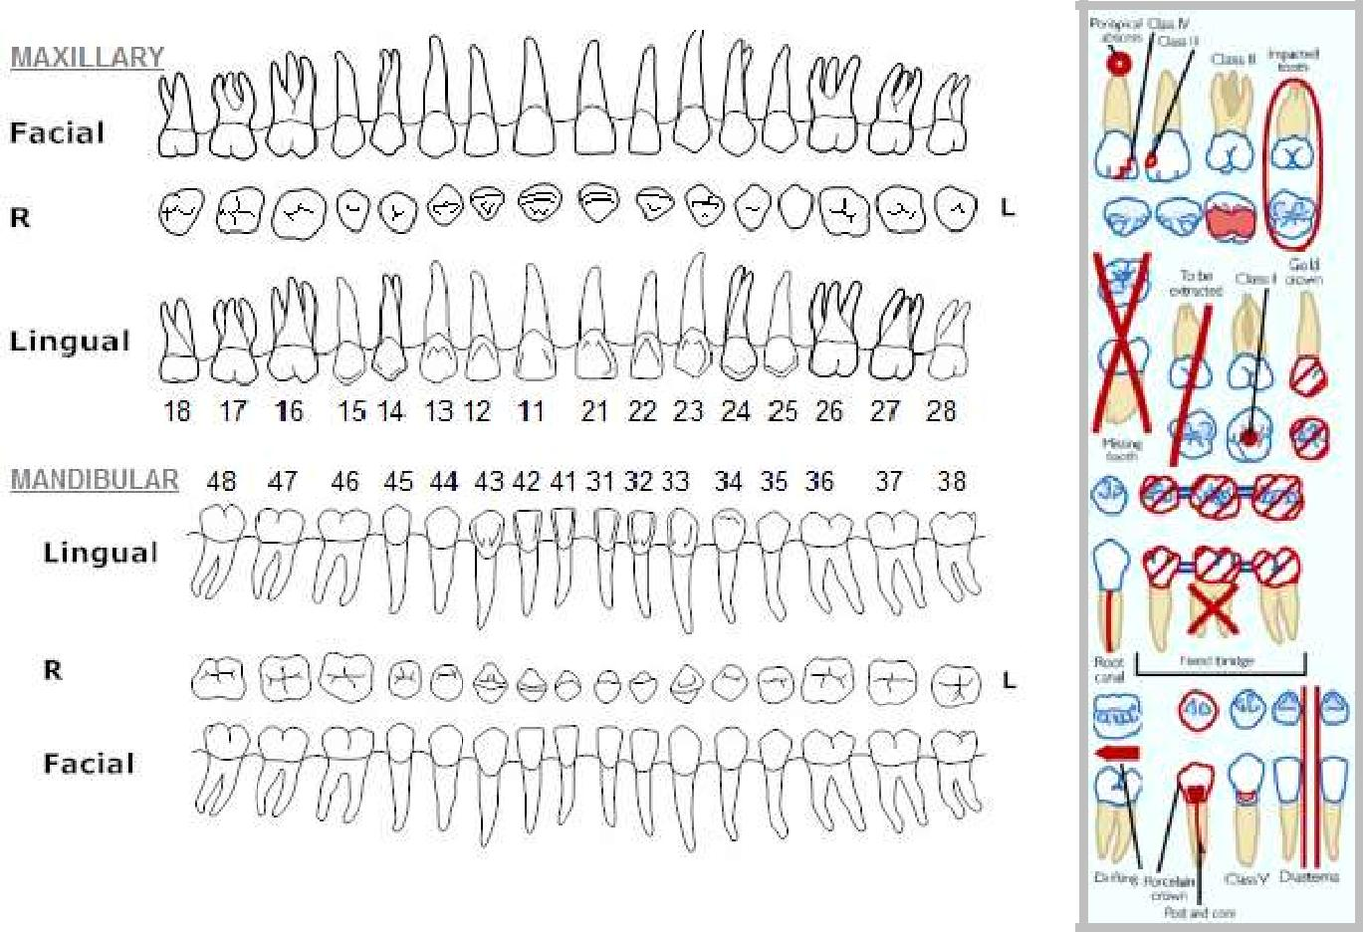

3. Relationship to anatomical structures:
- Inferior alveolar canal: ------------------------
- Mental foramen: --------------------------
- Maxillary sinus: --------------------------
- Nasal cavity: --------------------------------
Parallelism of adjacent teeth: __________________

Occlusal scheme:

Molar relation: ____________ Left: ____________ Right: ___________

- Initial periodontal examination:

Gingival inflammation: Slight/ Moderate / Severe
Soft plaque build-up: Slight/ Moderate / Severe
Hard calculus build-up: Slight/ Moderate / Severe
Stains: Light/ Moderate / Severe

- General dental considerations:

Occlusal plane: Favourable / Adequate /Unfavourable

Opposing dentition: Removable / Combination /Fixed

- Existing Prosthesis: Favourable / Adequate / Unfavourable

Pontics: 1 / 2 / 3 or more

Resting lip line: Low / Normal / High

High Lip Line (Smile) :Low / Normal / High

Low Lip line (Speech) :Low / Normal / High

Arch position: Class I / II / III

Arch form (Ant-Post): Tapering / Ovoid / Square

Crown Height Space: _____________________

- Investigations:

Diagnostic casts: ________________

Photographs (case related): _________________________________

Radiographs: OPG / IOPA / Full mouth series / CT scan / CBCT scan / Lateral cephalograms / Transcranial / MRI scan

Abutment teeth: Crown Ratio: ______________ Bone support:____________

Blood investigations:
Complete Blood Count: ___________________________________________
RBS: ___________________________________________
BT: ____________________________________________
Vital signs: ______________________________________
CT: ____________________________________________
PT: ____________________________________________
PTT: ___________________________________________

Special investigations:

Bone mapping (On the model):

Area | Length | Height | Width

Evaluation of available bone (radiographically):

Area | Length | Height | Width

- Diagnosis:

Maxillary:

Mandibular:
Implant treatment: Favourable / Unfavourable
- Treatment plan:

Artificial Graft: ________Artificial membrane: ________
Preoperative medication: _________________________________
Surgical template Preparation: ______________________
Anesthesia: L.A. /G.A.
Flap and Suture: _____________________
PROSTHETIC PHASE:

- Planned Rehabilitation:

- Cost:

- Impression:

Trays selected

Impression material used

Impression technique used

Important observations &

Special Problems

- Maxiilomandibular relation:

Orientation relation: yes/no Vertical Relation: yes/no Centric relation: yes/no

- Important observations & Special Problems:

- Articulator: mean value/ hanau wide view

- Healing abutments used: yes/no

- Specification of Abutments:

- Provisional restoration: yes/no

- Type of Permanent restoration:

- Teeth selection: Shade: _______________ Material: ______________

- Prognosis:

Name &Signature of Patient: ______________________________

Name & Signature of Doctor: ______________________________

Name And Signature of HOD:_______________________________

