NERVE
Nerve injury:
There are three types of nerve injuries.
- Neurapraxia.
- Axonotmesis.
- Neurotmesis.
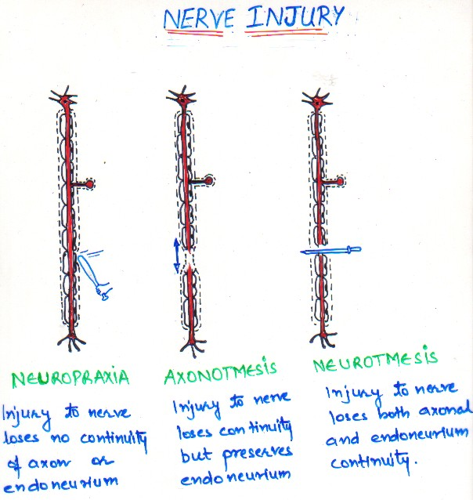
Neurapraxia : It is contusion of a nerve where continuity, of both the epineural sheath and the axons is maintained. It can be produced by blunt trauma or traction (stretching) of a nerve.
There is no loss of axonal continuity spontaneous full recovery of nerve function usually occurs in a few days or weeks.
Axonotmesis – Continuity of the axons but not the epineural sheath is disrupted. Injury produced by severe blunt trauma, nerve crushing, or extreme traction of the nerve. As the epineural sheath is still intact, axonal regeneration can but not always occur with a resolution of nerve dysfunction within 2 to 6 months.
Neurotmesis – Most severe type of nerve injury involves a complete loss of nerve continuity. Damage produced by badly displaced fractures. Severance by bullets or knives during an assault. Prognosis for spontaneous recovery of nerves is poor except if the ends of the affected nerve have been left in close approximation and properly oriented.
Nerve Healing:
These are two phases in nerve healing:
- Degeneration.
- Regeneration.
Two types of degeneration:
- Segmental degeneration: In this there is dissolution of the myelin sheath in isolated segments. The partial, demyelination causes a slowing of conduction velocity and may prevent the transmission of some nerve impulses.
Symptoms include:
Paresthesia (spontaneous and subjective altered sensation that a patient does not find painful).
Dysethesia – Spontaneous and subjective altered sensation that a patient finds painful.
Hyperesthesia – Excessive sensitivity of a nerve to stimulation.
Hyperesthesia : deciduous sensitivity of a nerve to stimulation.
- Wallerian degeneration: In this process the axons and myelin sheath of the nerve distal to the site of nerve trunk interruption undergo disintegration in their entirety. The axons proximal to the site of injury also undergo some degeneration, occasionally all the way to the cell body but generally just for a few nodes of Ranvier Wallerian degeneration, stops all nerve conduction distal to the proximal axonal stump.
Regeneration:
Regeneration of a peripheral nerve begins almost immediately after nerve injury. The proximal nerve stump sends out a group of new fibres which grow down the remnant Schwann Cell tube. Growth progress at a rate of 1 to 1.5mm per day and continues until the site innervated by the nerve is reached or growth is blocked by fibrous connective tissue or bone.
As functional contacts are made the patient with experience altered sensation in the previously anesthetic area.
Problems can occur during regeneration that prevent normal nerve healing.
If the continuity of the Schwann cell tube is disrupted connective tissue may enter the tube while it is partially vacant. When the growth cone reaches the connective tissue obstruction, it may find a way around it and continue on, or it may form a mass of aimless nerve fibers that constitutes a traumatic neuroma subject to pain production when disturbed.
