Seminar by Dr Manvi
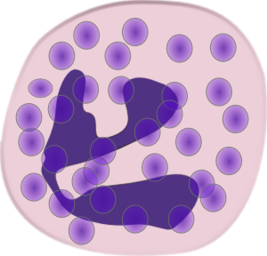
POLYMORPHONUCLEAR LEUKOCYTE DYSFUNCTION

CONTENTS
- Introduction
- Neutrophil Function
- Neutrophil Dysfunction And Laboratory Diagnosis
- Chediak-Higashi Syndrome
- Chronic Granulomatous Disease
- Hyperimmunoglobulin E Syndrome
- Chronic Neutropenias
- Chronic Benign Neutropenia
- Cyclic Neutropenia
- Congenital Neutropenia (Kostmann Syndrome)
- Felty’s Syndrome
- Lazy Leukocyte Syndrome
- Agranulocytosis
- Leukocyte Adhesion Deficiency
- Papillon-Lefevre Syndrome
- Down’s Syndrome
- Inflammatory Bowel Disease
- Systemic Lupus Erythematosus
- Myeloperoxidase Deficiency
- Glycogen Storage Disease Type 1b
- Acatalasia
- Conclusions & References

polymorphonuclear leukocyte (PMN) or neutrophil.

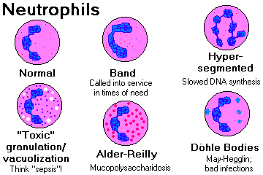

INTRODUCTION
It is well accepted that the tissue destruction characteristic of periodontal diseases is a result of an imbalance between the host inﬂammatory process and speciﬁc pathogenic bacteria residing in the periodontal crevicular space. The protective nature of the host response enables the majority of the population to fend off the bacterial insult that constantly threatens the health of the supporting tissues of the dentition. One of the major players on this inﬂammatory and immunologic battleground is the polymorphonuclear leukocyte (PMN) or neutrophil. Hart et al. in 1994, reviewed evidence placing the neutrophil in a central host response role against invading periodontal pathogens. The importance of this cellular defender in the pathogenesis of periodontal disease is dramatically brought to the forefront in those systemic diseases that are characterized by either an innate or an induced abnormality in the number and/or function of the neutrophil and a concomitant destruction of the periodontium. Although a relatively rare occurrence in clinical practice, the severe periodontal destruction associated with these disorders can be overwhelming for both the patient and the provider. Despite this, the periodontal manifestations often are of secondary importance given the life threatening nature of many of these diseases.
NEUTROPHIL FUNCTION
Neutrophils are short lived, non-mitotic cells generated in large numbers from pluripotential stem cells residing in the bone marrow. Undifferentiated stem cells become committed to a myeloid lineage through the inﬂuence of a combination of stem cell factors, interleukin (IL)-3, and granulocyte macrophage colony-stimulating factor.
Differentiation and maturation in the marrow involves the progression through ﬁve cellular precursors before the mature neutrophil is released. During this process of myelopoiesis, the neutrophil acquires the necessary capabilities to detect infection, migrate to the site of infection, and ingest and kill microorganisms.
The ﬁrst three stages comprise the proliferation phase of myelopoiesis: the precursor cells are termed myeloblast, promyelocyte, and myelocyte.
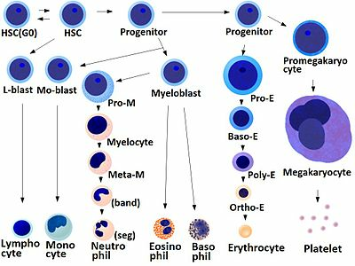

Neutrophil generation in bone marrow
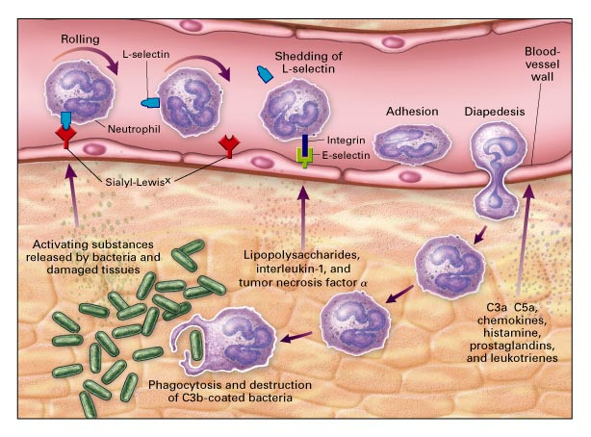
Migration of neutrophils into the site of damage or injury
The proliferation phase lasts approximately 1 week and involves active mitosis and the development of primary and secondary lysosomal granules. The next phase, a 1-week maturation process, starts with the differentiation of the myelocyte to form the meta-myelocyte and proceeds through the development of the band neutrophil and, ﬁnally, the mature segmented neutrophil. The three cell types in this ﬁnal phase lose their ability to divide. Approximately neutrophils are produced daily and this number may increase several fold in the face of a systemic infection. Under normal conditions, approximately 90% of the body’s neutrophils are in the bone marrow. Many of the daily produced neutrophils undergo apoptosis even before leaving the bonemarrow. For those neutrophils that are released, the half-life in circulation is six to nine hours. The tissue half-life varies from one to four days.
Mobilization of unstimulated neutrophils from the marrow into circulation is controlled by a variety of signaling factors such as IL-1, tumor necrosis factor- a (TNF-a), colony stimulating factors and complement fragments. In the face of infection, a complex array of vascular and extravascular events press the neutrophil into action as the ﬁrst line defender. Chemokines and other chemotactic substances released from the site of infection activate cell surface molecules on vascular endothelial cells and neutrophils leading to the movement of neutrophils to the periphery of the venule, a process called margination. Neutrophil and endothelial cell surface glycoproteins called selectins produce a low afﬁnity cell-to-cell interaction resulting in ‘‘rolling’’ of the neutrophil along the endothelial surface. This slowing of ./the neutrophil increases its exposure to inﬂammatory mediators such as histamine, IL-1, TNF-a, complement fragment C5a, leukotriene B4, IL-8, platelet activating factor and bacterial products. In response to these chemotactic stimuli, the adhesion of neutrophils is strengthened through the induction of b2 (CD18) and a (CD11a,b,c) integrin adhesion molecules. This adhesion to endothelial cells is mediated through interactions of neutrophil surface integrin complexes LFA-1 (CD11a/CD18), Mac-1 (CD11b/CD18), and perhaps p-150,95 (CD11c/CD18) with endothelial cell surface receptors ICAM-1 and 2, ELAM-1, and GMP-140.

Following adhesion to endothelial cells, the neutrophils ﬂatten out and begin to emigrate out of postcapillary venules by pushing pseudopods through intracellular junctions between the endothelial cells. This process of migration through the endothelium and into the extravascular

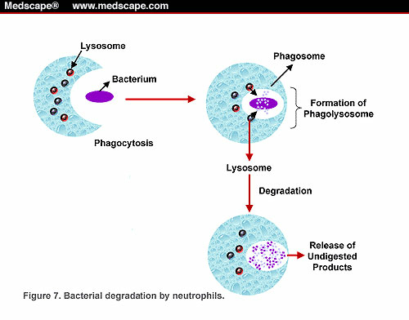

Phagocytosis of the bacteria
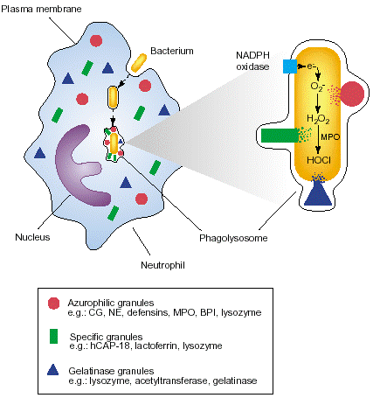

Degranulation and bacterial killing by the neutrophil
tissues iscalled diapedesis. Once into the tissues, chemotactic factors produced by both the host and bacterial pathogens bind to transmembrane receptors on the neutrophil. The end result is the movement of cell protoplasm in the direction of the chemoattractantsand locomotion of the cell through mechanisms mediated by intracellular microﬁlaments consisting of actin and myosin. Progression through the tissues may be directed principally by the integrin CD11b/CD18 on the cell surface. It is believed that C5a is involved in the initial recruitment of neutrophils and IL-8 is responsible for more prolonged recruitment over a 6–48-hour span.
Neutrophils have multiple surface receptors that enable them to bind to and phagocytize bacteria once they reach the site of infection. Serum factors called opsonins help trigger this process. Various immunoglobulins and complement fragment iC3b act as opsonins by binding to the bacteria and providing receptor sites for the neutrophils to attach. The phagocytic process is triggered when the immunoglobulin Fc fragment and iC3b receptor on the neutrophil bind to corresponding ligands attached to the bacteria. This facilitates adherence to the microbe and initiates the formation of pseudopods which surround the bacteria. If antibody or complement are not available, an alternative mode of opsonization involves neutrophil bound lipopolysaccharide binding protein attaching to bacterial lipopolysaccharide through a CD14 receptor. The process of endocytic invagination encapsulates the bacteria in a membrane bound phagolysosome.

Once engulfed, the bacteria are exposed to the neutrophil’s intracellular killing processes. Bacterial killing within the neutrophil involves two microbicidal systems:
- an oxygen-dependent respiratory burst resulting in the generation of free radicals, and
- an oxygen-independent release of enzymes intothe phagolysosome through degranulation of cytoplasmic primary and secondary granules.
If oxygen is available, phagocytosis is accompanied with a burst of oxygen consumption by the neutrophil. Membrane bound nicotinamide adenine dinucleotide phosphate (NADPH) oxidase catalyzes the reduction of oxygen to superoxide anion, which is then converted to hydrogen peroxide and hydroxyl radical.

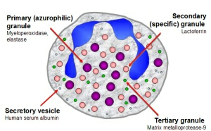

Granules found in neutrophils

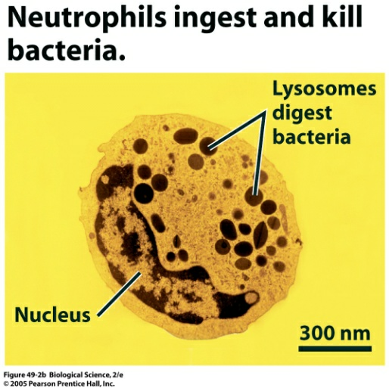

Although these free radical metabolites arebactericidal, the neutrophil’s main oxidative attack against bacteria involves the formation of hypochlorous acid, hypochlorite and chlorine. Hydrogenperoxide and chloride, in the presence of myeloperoxidase, form the powerful oxidant hypochlorous acid, which is a very effective bacterial killer.
Although the neutrophil respiratory burst is meant to protect the host from bacterial invasion, when uncontrolled it may lead to the destruction of host tissues. Two essential enzymes, superoxide dismutase and catalase, catalyze the breakdown of oxygen radicals and hydrogen peroxide to help protect the host from these toxic oxygen metabolites. The second intracellular killing mechanism in the neutrophil relies on the fusion of cytoplasmic granules with the phagocytic vacuole and the release of enzymes into the phagosome. This process, called degranulation, works concomitantly with the activation of the oxidative pathway described above.
Neutrophils contain several types of granules but most attention is given to the classic lysosomal granules called primary (azurophilic) granules and secondary (speciﬁc)granules. Primary granules are identiﬁed by their peroxidase content and contain acid hydrolases, elastase, cathepsin G, myloperoxidase, cationic proteins, neutral proteases, bactericidal/permeability-increasing protein, and other defensins. It is the contents of these primary granules that are primarily responsible for the non-oxidative killing mechanism possessed by the neutrophil. Secondary granules, which are peroxidase negative, contain lysozyme, lactoferrin, collagenase, alkaline phosphatase and vitamin B12 binding proteins and various adhesion proteins. These granules are more numerous than primary granulesand are primarily involved in extracellular killing. It is important to note that although these proteolytic enzymes in the primary and secondary granules are effective bacterial killers, they alsohave the potential to be very damaging to extracellular host tissues. This auto-destruction of host tissues has been proposed as an important pathogenic mechanism in periodontitis. An appropriate qualitative and quantitative response mounted by the host immune defense system is essential to the maintenance of a stable, healthy periodontium and the neutrophil appears to be a key player in this immune defense against periodontal pathogens. Either an inadequate or an excessive host response, including defective or deﬁcient neutrophil function, can potentially lead to destruction of the periodontal tissues.

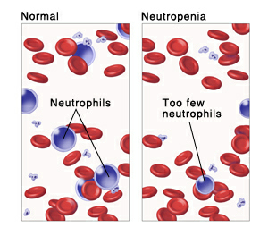

NEUTROPHIL DYSFUNCTION AND LABORATORY DIAGNOSIS
The neutrophil’s employment of specialized features enabling their destruction of invading organisms can be divided into six stages or functions:
1. rolling along vascular endothelium,
2. adherence to the endothelial lining,
3. migration (chemotaxis) toward the site of theinfection,
4. adherence to microorganisms,
5. engulfment of bacteria (phagocytosis), and
6. intracellular killing.
Defects in any of these functions or a marked decrease in the number of neutrophils capable of responding to the site of infection may result in varying degrees of susceptibility to infection. These qualitative and quantitative defects may be inherited, acquired, or drug-induced.
A relative deﬁciency in neutrophil number candramatically increase susceptibility to infectious diseases. Neutropeniais considered clinically signiﬁcant when the absolute neutrophil count fallsbelow 1,000 cells/ml (normal adult range: 1,800–8,000 cells/ml). When the absolute neutrophil count is less than 500 cells/ml, control of endogenous microbiota is often impaired and the risk for serious infection increases. An absolute neutrophil count less than 200 cells/ml corresponds with an inability to mount an inﬂammatory response. Neutropenia can be an inherited, congenital disorder or acquired secondary to infection, malignancy, certain medications, autoimmune disease, nutritional deﬁciencies or hematopoetic disease. The pathophysiology of neutropenia may be classiﬁed asabnormalities of bone marrow stem cell development,impaired release of neutrophils from the bonemarrow,abnormalities in distribution of neutrophils between the circulating and marginating pool inthe blood, and decreased survival of neutrophils in the blood.Diagnosis of neutropenia is based on clinical signsand symptoms as well as absolute neutrophil counts.
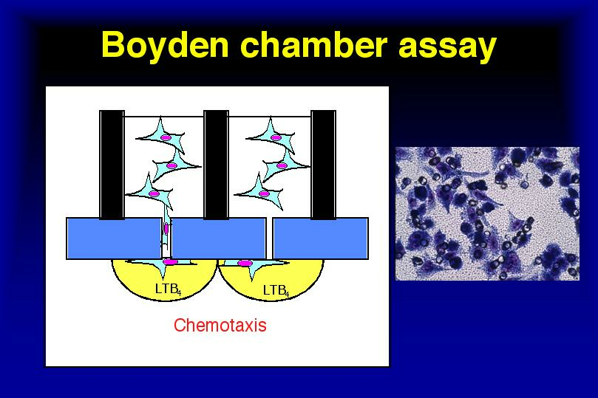

Qualitative disorders of neutrophil function also increase the host’s susceptibility to infection. Classiﬁcation of neutrophil disorders corresponds with the major neutrophil processes: margination (rolling and adhesion), chemotaxis and migration, phagocytosis, degranulation and killing.
Defects in the process of margination can occur at two levels. The ﬁrst is a defect in a speciﬁc neutrophil ligand called the sialy-Lewis x protein (CD15s). A defect in this glycoprotein will result in the loss of the neutrophil’s ability to ‘‘roll’’ along the endothelial lining of venules. Alterations in the selectin-mediated rolling function prevent the neutrophil’s egress from the venules. The defect is detected through ﬂow cytometry using a commercially available monoclonal antibody directed against the membrane surface antigens associated with CD15s. The disease associated with this deﬁcit is leukocyte adhesion deﬁciency type 2 (LAD-II).
The second neutrophil defect involving margination is at the level of neutrophil adhesion to the endothelial cell. Defects in neutrophil surface integrins CD18/CD11a, CD18/CD11b, and CD18/CD11c prevent the neutrophil from adhering to the endothelium. Inability to adhere to endothelial cells prevents the migration of neutrophils to the site of infection. In addition, since these integrins are also responsible for neutrophil adhesion to opsonized bacteria, the neutrophil’s ability to phagocytize bacteria is compromised. Defects on CD18 and CD11 peptides are also identiﬁed by ﬂow cytometry. Deﬁciency of these intergrins is termed LAD-I.
Deﬁcits in neutrophil chemotaxis can be either inherited, or secondary to a number of other neutrophil defects caused by a variety of diseases or medications. Any alteration in the neutrophilcytoskeleton or its ability to sense or respond to achemotactic gradient will interfere with the cell’s ability to reach the site of infection.
Neutrophil chemotactic deﬁcits are diagnosed
- in vivo through the use of the Rebuck skin window or
- in the laboratory using a Boyden chamber or the agarose technique.
The Rebuck skin window measures the movement of neutrophils on a glass slide or coverslip applied to a superﬁcial abrasion made on the patient’s skin. The Boyden chamber evaluates chemotaxis by quantifying the migration of neutrophils from an upper chamber,
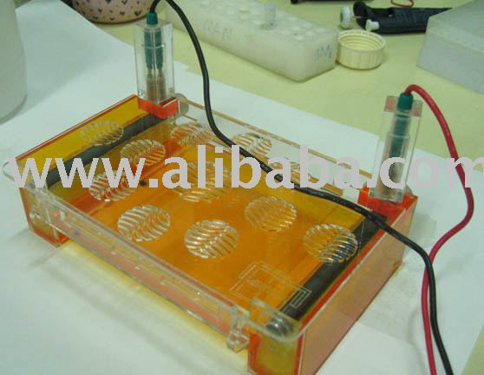

Agarose gel electrophoresis

through a micropore ﬁlter, into a lower chamber containing a chemoattractant. After incubation of the chamber, the ﬁlter paper is removed and stained. The number of neutrophils are counted under light microscopy.
An additional in vitro method for assessing neutrophil chemotaxis is the agarose technique. Blood samples under study are placed into a central well punched into a layer of agarose. Neutrophils migrate under the agarose toward peripheral wells containing a chemoattractant and are quantiﬁed.
Primary defects in neutrophil phagocytosis arerare. Impairment of phagocytic function is usuallycaused by deﬁciencies in certain immunoglobulin isotypes and other opsonization factors rather than intrinsic defects in the neutrophil. Assays of phagocytosis utilize either inert particles (stained oil droplets, ﬂuorescent microspheres, latex beads) or radiolabeled microorganisms (bacteria, yeast) that are detectable within the cell after phagocytosis. Following incubation, the ingested particles are quantiﬁed to determine if phagocytosis is impaired.
Defects in intracellular killing can be divided into those disorders affecting the oxidative or non-oxidative pathways. Degranulation within the neutrophil is a non-oxidative function. There are two main conditions with defects in degranulation – Chediak-Higashi syndrome and speciﬁc granule deﬁciency. Chediak-Higashi syndrome is characterized by fusion of cytoplasmic granules forming large but defective granules. Degranulation is either delayed or incomplete, leading to impaired intracellular killing. This neutrophil disorder is diagnosed with peripheral blood smears to identify the large azurphiliccytoplasmic granules.
Speciﬁc granule deﬁciencymanifests in the absence of secondary or speciﬁc granules. In this disease, there is decreased availability of speciﬁc enzymes and adhesionmolecules normally present in secondary granules. Diagnosis of speciﬁc granule deﬁciency is through the use of Wright stain conﬁrming the absence of secondary granules. Assays for constituent proteins of these granules should also demonstrate a reduction or absence compared to normally functioning neutrophils. The neutrophil’s oxidative killing mechanisminvolves two main enzymes that, in rare instances,can be dysfunctional. The ﬁrst involves defects in theﬁve components of of the complex enzyme NADPH oxidase. As previously mentioned, NADPH oxidase catalyzes the respiratory burst with the production of microbicidal superoxide anion, hydrogen peroxide and
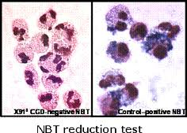
Diagnostic test for oxidative metabolism

Chediak – Higashi syndrome
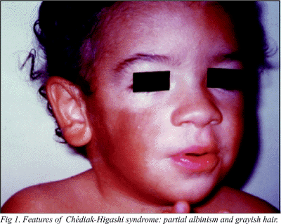

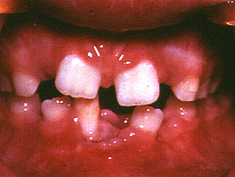

hydroxyl radical. Without this oxidative reaction, bacterial killing is greatly impaired. This neutrophil defect is responsible for the life threatening recurrent infections found in chronic granulomatous disease.
Diagnostic tests for oxidative metabolism include the nitroblue tetrazolium test. In this test, neutrophils are stimulated and incubated with the colorless nitroblue tetrazolium. If NADPH oxidase is functioning, the nitroblue tetrazolium is reduced, leaving a blue black formazan precipitate. If the oxidative burst is defective, no precipitate is formed. A more sensitive test to measure the respiratory burst involves ﬂow cytometry. Hydrogen peroxide converts dihydrorhodamine to rhodamine and this is detected using a ﬂorescent label.
Another deﬁciency in the oxidative pathway is the absence of myeloperoxidase. A deﬁcit of this enzyme will lead to a lack of hypochlorous acid and a delay in bacterial killing. Myeloperoxidase deﬁciency is diagnosed using peroxidase staining of blood ﬁlms, ﬂow cytometry or direct assay of enzyme activity. While there are numerous diseases related to deﬁciencies in both neutrophil number and function, only a few have been speciﬁcally related to periodontal disease in the medical and dental literature.
CHEDIAK-HIGASHI SYNDROME
Chediak-Higashi syndrome is a rare autosomal recessive disorder that primarily affects neutrophils. Its genetic etiology manifests itself early in lifein the form of partial oculocutaneous albinism, photophobia, frequent pyogenic infections and lymphadenopathy. Oral ﬁndings include severe gingivitis, ulcerations of the tongue and buccal mucosa, and early onset periodontitis leading to premature loss of both deciduous and permanent dentitions.
Thesyndrome was ﬁrst described by Beguez-Cesar in1943, but acquired its name 10 years later from separate reports by Chediak in 1952 and Higashi in 1954,which described the same condition. Only200 cases have been reported through 1998.Clinically, the syndrome may present as abnormalities of pigmentation, recurrent infections, andbleeding tendencies. Oculocutaneous albinismcan affect the skin, eyes, and hair. Hair color is characteristically metallic silver, the skin color white togray due to defective melanosomes, and the eyes areaffected by reduced pigmentation of the retina andiris. Other ocular abnormalities can include nystagmus, photophobia and reduced visual acuity. Infections are commonly skin abscesses,

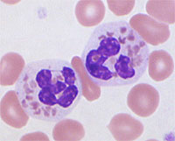

Neutrophils with azurophilic inclusions

pneumonias,otitis media and sinusitis. Bleeding problems arisebecause of organelle abnormalities within plateletsthat inhibit normal clot formation. Peripheral orcranial neuropathies may develop similar to thoseseen in Parkinson’s disease. Weakness,sensory deﬁcits, clumsiness, a wide-based gait, seizures and tremors have also been reported.
The average lifespan for children with Chediak-Higashi syndrome is only 6 years. The fewindividuals that do survive beyond the ﬁrst decadeoften progress to a lymphoma-like disease known asthe accelerated phase. This phase can include fever,jaundice, hepatosplenomegaly, and pancytopeniathat leads to an even greater susceptibility to infection.
On a cellular level, organelle abnormalities, speciﬁcally of lysosomes, are present in cells throughout the body. One of the hallmarks of the Chediak-Higashi syndrome is the presence of large intracellular azurophilic inclusions in the cytoplasm of neutrophils. These large inclusions impair neutrophilmigration, possibly by inhibiting cell deformability, and render neutrophils unable to metabolizeand digest microbes. As a result, patients with Chediak-Higashi syndrome are prone to recurrent infections in early childhood.
Animal research has ledto the determination that a mutation in the LYST(lysosome trafﬁcking regulation) gene, the onlyknown Chediak-Higashi syndrome-causing gene,may be responsible for this phenomenon. Bonemarrow transplantation appears to be the most effective treatment for correcting these neutrophilabnormalities.
Dental case reports include that of a 10-year-oldChediak-Higashi syndrome patient suffering fromdental pain, swollen gingiva with frank purulence,severe horizontal bone loss and lymphadenopathy. More recently, Delcourt-Debruyne et al. examined a 14-year-old Chediak-Higashi syndromepatient with severe mobility of the teeth, suppuration, severe bone loss, and generalized recession withdeep probing depths. Laboratory reports conﬁrmed the presence of large granules within the neutrophils.
Shibutani et al. presented a 12-year follow up of a21-year-old woman with Chediak-Higashi syndrome. At age 9 the patient presented complaining ofgingival swelling and mobility of teeth. By age 12,severe bone loss was present throughout botharches. DNA probe analysis of the bacteria withinthe periodontal pockets revealed a pathogenic ﬂoraconsisting of Actinobacillusactinomycetemcomitans,Porphyromonasgingivalis and Prevotella intermedia.In

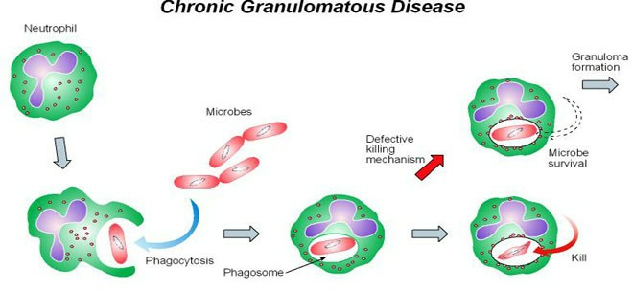

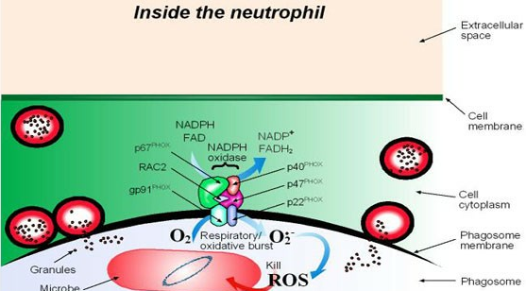

spite of ongoing treatment, she experiencedmultiple abscesses and extractions of hopeless teeth overthe next 12 years. Unfortunately, the outcome of thiscase is rather typical, and the ﬁnal fate for mostpatients with Chediak-Higashi syndrome is toothextraction.
CHRONIC GRANULOMATOUS DISEASE
Chronic granulomatous disease is an extremely rareclinical syndrome characterized by life-threateningStaphylococcus, Proteus or Pseudomonas speciesinfections, hypergammaglobulinemia, and widespread chronic granulomatous inﬁltrations. Variedincidences have been reported ranging from one in200,000 to one in a million births.
Chronic granulomatous disease is caused by congenital defects in the enzyme NADPH oxidase. Thedefect prevents free oxygen radicals from being produced, and the neutrophil’s inability to kill intracellular organisms predisposes patients to recurrentbacterial and fungal infections. In about two thirdsof the cases, chronic granulomatous disease occursas an X-linked recessive disease, while the remainingone third of cases are inherited in an autosomal recessive fashion.
Chronic granulomatous disease usually presents inthe ﬁrst year of life with recurrent bacterial and fungal infections including pneumonia, lymphadenitis,liver abscess, osteomyelitis, septicemia, and otitismedia. The most common pathogens encountered are Staphylococcus aureus, Aspergillusspecies, and enteric gram-negative bacteria. Theclassic granulomas that give this condition its nameare caused by a chronic, ineffective inﬂammatory response to these pathogens. The most common presenting feature is lymphadenitis, followed byskin abscesses and pneumonia.
Treatment of chronic granulomatous disease centers on control of infections. One useful antibiotic iscotrimoxazole, which has a broad spectrum of activity against many of the causative organisms, yet aminimal affect on the gastrointestinal ﬂora.Antifungal prophylaxis can be achieved with itraconazole. Interferon-g has been shown to partiallyrestore oxidase activity in neutrophils and monocytes of some patients with X-linked chronic granulomatous disease, and to reduce infection rates. Although corticosteroids are avoided in mostinstances, they can be useful in low doses to managesymptomatic complications of granuloma formationsuch as colitis and hollow organ obstruction. Bone marrow transplantation, effective in treating
HYPERIMMUNOGLOBULIN E SYNDROME
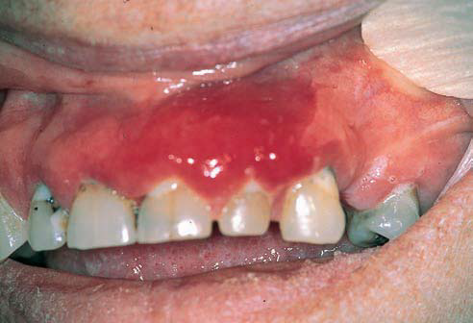

Cold abscesses

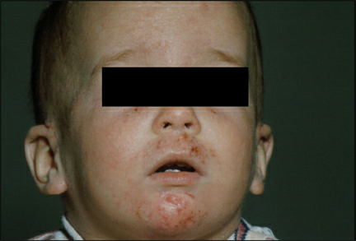

Eczematoid dermatitis

some cases of chronic granulomatous disease,has become a more predictable treatment during the past decade.
Oral complications of chronic granulomatous disease have been described. Charon et al. reported onnine patients from the National Institute of Allergyand Infectious Diseases Study who were diagnosedwith chronic granulomatous disease. Patients had a signiﬁcantly greater occurrence of oral ulcerations andgingival inﬂammation compared to controls. Budonelli et al. reported the case of a 5-year-old Caucasianmale diagnosed with chronic granulomatous diseasefrom the laboratory ﬁndings of hypergammaglobulinemia and a low neutrophil burst test. Severegingival inﬂammation and marginal erythemawere noted, along with extensive attachment lossand gingival recession that resulted in signiﬁcantmobility and furcation involvement. Several of the patients had oral ulcerations on thepalate and alveolar mucosa. Generalized inﬂammation of the gingiva was present with bleeding uponprobing. Limited mild periodontitis was noted andwas consistent with local factors present. In thisstudy there was not an association between severeperiodontitis and chronic granulomatous disease.
HYPERIMMUNOGLOBULIN E SYNDROME
Hyperimmunoglobulin E syndrome is a multisystemdisorder inherited as an autosomal dominant traitthat affects the dentition, the skeleton, connective tissues, and immune system. Classically, it hasbeen characterized by a triad of symptoms includingskin abscesses, pneumonia, and elevated serumimmunoglobulin E levels. Eosinophilia, candidiasis, arthritis, chronic eczematoid dermatitis andother recurrent infections are also common. Typically, patients have coarse facial skin with prominentpores. Other common ﬁndings include facial asymmetry, prominent forehead, deep-set eyes, broadnasal bridge and mild prognathism. A decrease inbone density is common, leading to a high incidenceof long bone fractures.
Clinically, the appearance of the soft tissue lesionsis rather unique. Often described as ‘‘cold abscesses’’, these deep soft tissue lesions present as ﬂuctuant masses that may be mistaken for cysts ortumors. These abscesses, typically caused by S. aureus, often lack the usual signs of inﬂammation, suchas warmth, erythema, and tenderness. Extension ofthese lesions into bone may occur giving rise to an osteomyelitis.

Impairment of Th-17 differentiation
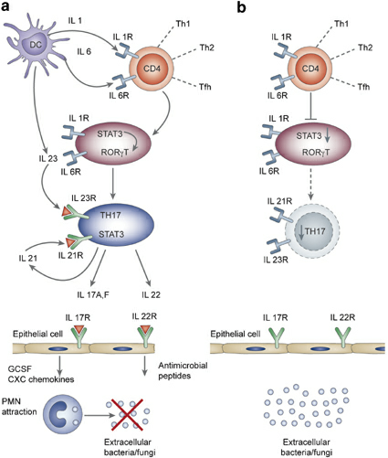

Recurrent infection is one of the chief features ofhyperimmunoglobulin E syndrome. While patientsmay go years between infections, a series of casesreviewed by the National Institute of Healthobserved that local infections requiring oral antibiotics occurred on average every 3.6 months and amajor infection occurred once per year.
Certainly contributing to the high rate of recurrentinfections in hyperimmunoglobulin E patients is adefect in neutrophil chemotaxis. Three hypotheses exist for the chemotactic defect in the neutrophils:
- A speciﬁc IgE against an infecting bacterium (S.aureus) causes the release of histamine that mayinhibit neutrophil chemotaxis.
- Bacterial antigens cause monocytes to secretechemotaxis inhibiting mediators or IgG.
- Mononuclear cells may create a speciﬁc factorwhich inhibits neutrophil chemotaxis.
Treatment of hyperimmunoglobulin E syndromeis dependent upon antibiotics, local debridement,and surgical incision and drainage of infections. Improvement following treatment with cimetidine or ranitidine alone or in combination withH1-receptor antagonists has also been reported.
Oral ﬁndings in hyperimmunoglobulin E patientsinclude ulcerations and gingivitis. Interestingly,there is a case of over-retention of primary teethin a patient with hyperimmunoglobulin E. Failure to shed the primary dentition in this case, incontrast with the early loss of primary teeth due toperiodontitis seen in other disorders of hostdefenses, is surprising. Although an increased susceptibility to severe periodontitis would certainly beconsistent with the neutrophil defect seen in patients with hyperimmunoglobulin E, the few casesreported in the literature are not unanimous in thisﬁnding.
CHRONIC NEUTROPENIAS
Chronic neutropenia is deﬁned as a low absoluteneutrophil count for greater than 6 months. The riskof infection due to neutropenia is typically inverselyproportional to the absolute neutrophil count. Speciﬁcally, the risk of stomatitis, gingivitis, and cellulitisincreases when the absolute neutrophil count<1000 cells/ml. The frequency of more serious infections such as pneumonia, peri-rectal abscess, andsepsis increases when the absolute neutrophil count

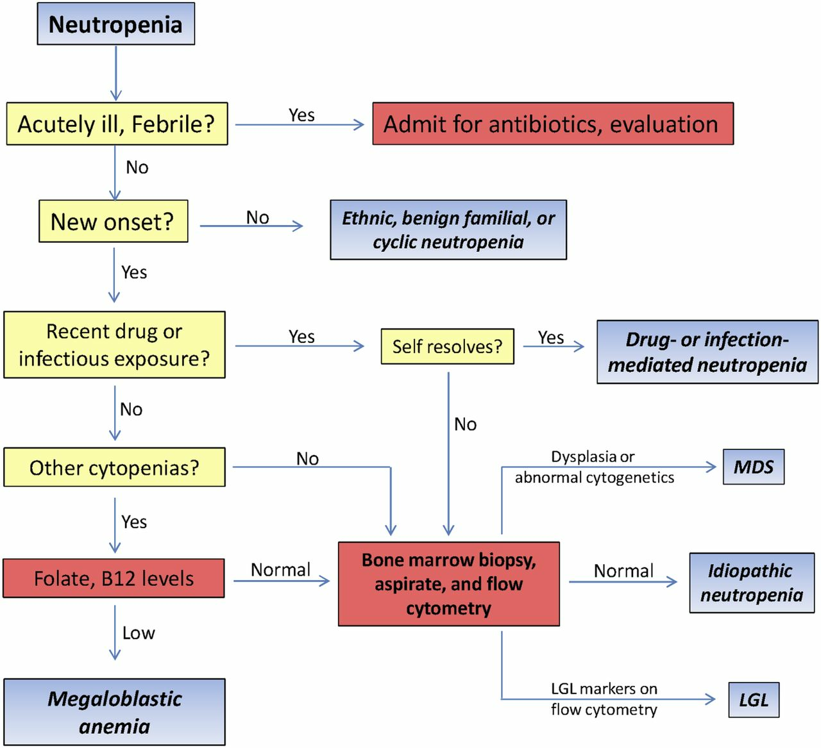

<500/ml. While any neutropenic episode canpredispose a patient to recurring infections, the neutropenic conditions listed below have been speciﬁcally identiﬁed in the dental literature as having oralcomplications.
CHRONIC BENIGN NEUTROPENIA
Chronic benign neutropenia is characterized by aprolonged noncyclic neutropenia as the soleabnormality, with no underlying disease to whichthe neutropenia can be attributed. It is the mostcommon form of neutropenia of infants and childrenless than 4 years old, with 90% of the cases presentingbefore 14 months of age. The incidence ofchronic benign neutropenia is 3.9 per 100,000 births. Chronic benign neutropenia is usually not inherited; however, the familial form followsan autosomal dominant mode of inheritance.
Familial chronic benign neutropenia was ﬁrstreported by Glansslen in 1941 and then by Bousser et al. in 1947. The clinical presentation canbe quite variable, froma benign condition discoveredincidentally to an early life-threatening infection, butmost patients with chronic benign neutropenia willlive a normal lifespan. Individuals may suffer fromincreased incidences of recurrent oral ulcerations,furuncles, upper respiratory infections, otitis media,cellulitis, lymphadenopathy, pneumonia and sepsisas a result of the limited neutrophil response toinfection. Fortunately, as these individuals getolder, the risk of infection appears to decrease.
Diagnosis of chronic benign neutropenia is madeby a persistent absolute neutrophil count <500/mlwith a normal total white blood cell count due toelevated numbers of lymphocytes and monocytes. A possible causative agent for this condition is anti-neutrophil antibodies, typically IgG, which have been found in 80–100% of patients tested.
Oral manifestations of chronic benignneutropeniainclude hyperplastic, edematous, and ﬁery-red gingiva with areas of desquamation.Deasy describeda 14-year-old boy with chronic benign neutropeniawho was referred due to severe gingival inﬂammation, hyperplastic papillae, isolated areas of gingivalrecession, and a molar furcal lesion. Reichart et al. reported on a 7-year-old boy with chronicgingivitis, periodontitis with 8 mm probing depths,severe horizontal bone loss, and extreme mobility ofthe deciduous teeth.
CYCLIC NEUTROPENIA

Oral and Radiographic findings in Cyclic neutropenia

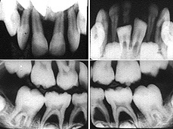

Cyclic neutropenia is a rare blood disease characterized by periodic recurring symptoms of fever,malaise, mucosal ulcers, and possibly life-threatening infections related to the regular cyclical ﬂuctuations in the numbers of neutrophils. Thedisease is transmitted via an autosomal dominantmode of inheritance and its incidence is 0.5–1case per million. Cyclic neutropenia is causedby the periodic oscillations in both bone marrowproduction and release of mature neutrophils, probably associated with the oscillation of other bloodcells, such as monocytes, eosinophils, lymphocytes and platelets. Bone marrow progenitor cellsare present in high concentrations; however, theseprecursor cells seem periodically unable to respondto granulocyte colony-stimulating factor.
This condition was ﬁrst reported byLeale in 1910,who described a persistent furunculosis in an infant. Cyclic neutropenia usually presents before age10 with episodes of fever, malaise, mood swings, andoral ulcerations that can last 3–6 days and recurapproximately every 3 weeks. The interval betweenneutropenic episodes is not always obvious and mayrequire a determined effort and frequent laboratorystudies to identify. The disease tends toimprove with age, although death can occur in asmany as 10% of affected individuals as a result ofpneumonia, cellulitis, gangrene, or peritonitis.
Diagnosis requires complete blood counts twice aweek for 6 weeks in order to observe the ﬂuctuationin neutrophil counts. For the majority of thesepatients, there is a 21-day cycle with severe neutropenia persisting for 3–10 days. Treatment toincrease neutrophil levels has been successful usingrecombinant human granulocyte colony-stimulatingfactor given 3 times per week. Gammaglobulin infusions have also been given to effect a short-lived increase in neutrophils in an urgent situation.
Case reports of oral conditions include a recentdescription of a 2-year-old that presented with recurrent gingivitis and aphthous lesions. Clinically, norecession was noted and probing depths were withinnormal limits. Analysis of the microbial ﬂora foundP. intermedia, Campylobacter rectus, Capnocytophagagingivalis, and Capnocytophagasputigena.Inspite of treatment, the child continued to experiencegingivitis during 2 years of follow-up. Numerous other case reports have documented patientswith a history of marked gingival inﬂammation,fever, oral ulcerations, otitis media, and upperrespiratory infections associated with cyclic

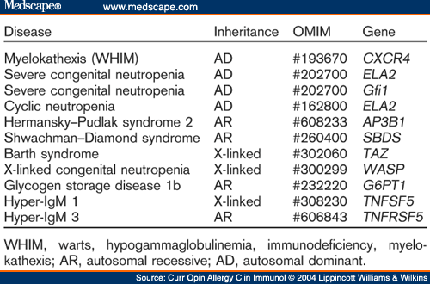
Pattern of genetic inheritance

neutropenia. Unfortunately, even withthe best of professional and home care, teeth areoften lost due to advancing periodontal disease.

CONGENITAL NEUTROPENIA (KOSTMANN SYNDROME)
Congenital neutropenia (Kostmann syndrome) wasnamed for the Swedish pediatrician who ﬁrstdescribed the disease in 1950. Congenital neutropenia is an inherited hematologic disorder manifesting in the ﬁrst year of life and characterized bysevere bacterial infections. The signiﬁcant laboratoryﬁndings are an absolute neutrophil count of less than2,000/ml and an arrest of neutrophil hematopoiesis atthe promyelocyte/myelocyte stage. The estimatedfrequency of congenital neutropenia is one – twocases per million in the general population with nosex predilection. While the disease as originallydescribed by Kostmann appeared to be inherited asan autosomal recessive trait, the diagnosis is nowused for similar cases without a deﬁned pattern of inheritance.
In most cases of congenital neutropenia, theunderlying mechanism of the syndrome is unknown.While most of the originally reported cases died ininfancy, aggressive treatment with antibiotics hasmore recently prolonged the lifespan of children suffering from this disease. In 1987, physiciansbegan to treat congenital neutropenias with granulocyte colony-stimulating factor, which is effective atincreasing the absolute neutrophil count above1,000/ml in most patients. Even though granulocytecolony-stimulating factor treatment results in anoverall improvement in symptoms, the therapy isnot curative and most patients experience cyclicimprovements followed by relapses in neutrophillevels.
Oral symptoms are virtually universal in congenitalneutropenia. In a recent report by Carlsson&Fasth, all of the patients that survived infancywere affected by gingivitis, and most were noted tohave periodontitis with alveolar bone loss. Anotherrecent case report demonstrated generalized severeperiodontitis in an adolescent patient with congenital neutropenia. Even with granulocyte colony-stimulating factor treatment, most of these patients

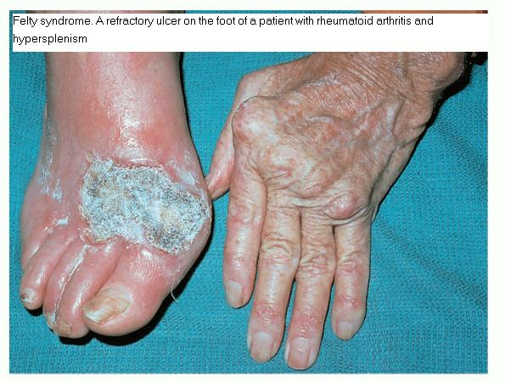

have persistent gingivitis, which tends to wax andwane depending on their absolute neutrophilcounts.
FELTY’S SYNDROME
Felty’s syndrome is an uncommon complication ofrheumatoid arthritis, in which splenomegaly and leukopenia are the major additional features. Theincidence of Felty’s syndrome is in about 1% of allrheumatoid arthritis cases. In addition to thedistinguishing triad of symptoms listed above, various case reports have listed other recurring signsand symptoms including weight loss, progressiveweakness, hyperpigmentation of the skin, generalized lymphadenopathy, hepatomegaly, increasedsusceptibility to infection, and a variety of abnormalities in white blood cell count and function.
The leukopenia noted in Felty’s syndrome is primarily due to a lack of circulating neutrophils. Several mechanisms have been suggested to explain thisphenomenon, including insufﬁcient formation ofneutrophils, reduced release of neutrophils fromthe bone marrow, a shortened neutrophil life span,and excessive neutrophil margination. In orderto study the relative mechanisms of neutrophil dysfunction and their effects on the susceptibility ofFelty’s syndrome patients to infection, Breedveldet al. monitored a variety of hematologic parameters in a group of 15 patients at 3-month intervalsfor 3 years. Relating the presence of infections inthese patients to laboratory values, the authors determined that the risk of infection was best correlatedwith neutrophil counts <1,000/ml, rather than somefunctional deﬁciency of neutrophil cells.
The pathogenesis of neutropeniain Felty’s syndrome patients appears to be the subject of debate. Coakley et al. and Kumakara et al. listedthe possible causes as anti-neutrophil antibodies,serum inhibitory factors directed against neutrophilprecursors, suppressor action by cytotoxic T-cells,or even phagocytosis of neutrophils within the bonemarrow.
Treatment of the neutropenia associated withFelty’s syndrome varies considerably. As mentionedearlier, not all Felty’s syndrome patients have theextreme neutropenia that predisposes them to infections. For those who do, splenectomy has beensuccessful at increasing the neutrophil count andrelieving symptoms in up to 80% of patients. Drugtherapy has included lithium carbonate, gammaglobulin, corticosteroids, and cyclophosphamide.More recently,

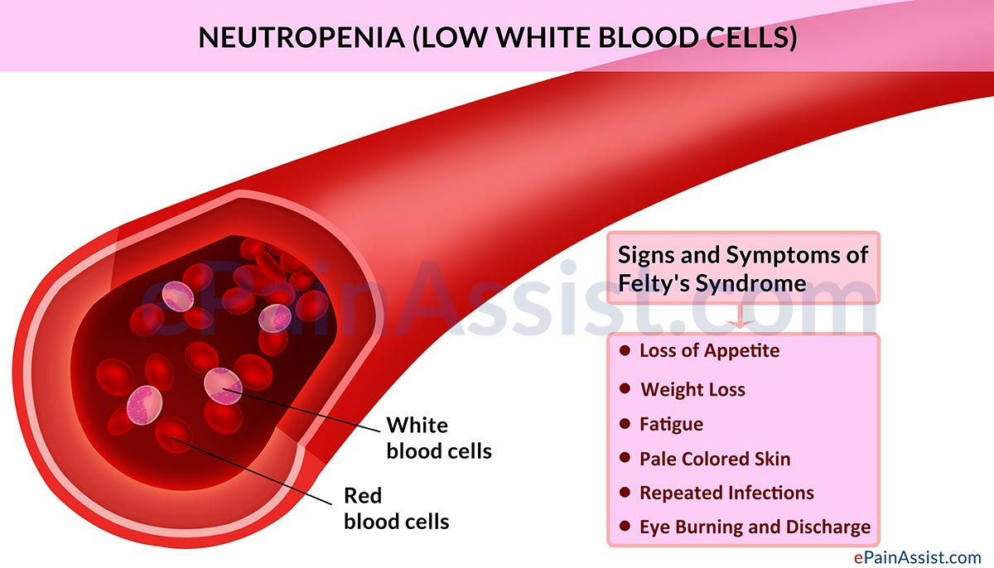

successful outcomes have been notedwith the use of recombinant granulocyte colony-stimulating factor, although signiﬁcant side effects havebeen noted in some Felty’s syndrome patients.
While oral ulceration and ‘‘stomatitis’’ are frequently mentioned in reports of Felty’s syndrome, periodontitis has only rarely beenimplied. Even so, it can be assumed that withthe dramatic deﬁciency in circulating neutrophilsnoted in some patients, the incidence of periodontitis is as at least as great in Felty’s syndrome patientsas in others with severe neutropenias.
LAZY LEUKOCYTE SYNDROME
Lazy leukocyte syndrome is an extremely rare disorder that manifests in both quantitative and qualitative neutrophil defects. Lazy leukocyte syndrome ischaracterized by recurrent infections due to both adeﬁciency in neutrophil chemotaxis and a systemicneutropenia, while the phagocytic function of theneutrophil remains intact. Within the bonemarrow, the quantity and morphology of the neutrophils are normal. Peripherally, however, there existsnot only a severe neutropenia but also functionaldefects of neutrophils with regard to chemotaxisand random migration. Directional locomotionis thought to be dependent on microtubule assemblywithin the neutrophil, while the random movementrelies on actin/myosin-like microﬁlaments associated with the cytoplasmic surface of the cell membrane. The abnormal function of thesemicroﬁlaments leads to a defect in cell deformability,and this hinders the release of newly formed neutrophils from the bone marrow. Impaired randomand directional motility leads to a diminished in vivomigration of neutrophils into the tissue and to sitesof inﬂammation.
Very few cases of lazy leukocyte syndrome havebeen reported, but each has had oral manifestations.Constantopoulous et al. described a 5-month-oldboy that presented with a high fever, cough, bilateralpneumonia, oral stomatitis and purulent skinabscesses. Laboratory tests revealed a peripheralneutropenia, and impairment of both neutrophilchemotaxis and random motility. A similar casereport is that of a 4-year-old diagnosed with lazyleukocyte syndrome and followed over 7 years. Theboy suffered from painful stomatitis, gingivitis andrecurrent ulcerations of the buccal mucosa and tongue. Periodontitis progressed to the point ofadvanced alveolar bone loss and tooth loss by theage of 7. Other cases describe similar signs and

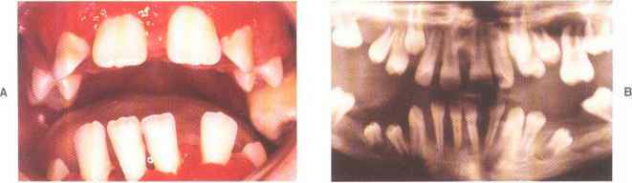
Severe periodontitis and tooth loss in agranulocytosis

symptoms, and the prognosis for the dentitionof patients with lazy leukocyte syndrome appearspoor.
AGRANULOCYTOSIS
Agranulocytosis is a blood dyscrasia characterized bya decrease in or even the disappearance of granularleukocytes (including neutrophils) in conjunctionwith peripheral leukopenia. The decreased number of granulocytes can result from either adecreased production or an increased peripheraldestruction of cells. Decreased production of granulocytes is usually due to bone marrow hypoplasia, although drugs, chemicals, ionizing radiation,infection, vitamin deﬁciencies, and bone marrowtumors can cause similar effects.
Clinically, patients with agranulocytosis do notalways present with the usual signs and symptoms of infection. Patients often are febrile and mayexhibit necrotizing, gangrenous lesions of mucousmembranes, to include oral, gastrointestinal, andvaginal membranes, but without purulence. Oralsigns and symptoms include generalized, painful stomatitis, spontaneous bleeding and necrotic tissue.
Radiographs generally reveal a progressive patternof bone loss at an early age. Depending on thecause and duration of the agranulocytosis, severeperiodontitis and tooth loss can be expected.
LEUKOCYTE ADHESION DEFICIENCY
In 1979, a group of patients with similar symptoms ofdelayed umbilical cord separation and persistent bacterial infections in the absence of pus formation werefound to share a common neutrophil motility defect. The name leukocyte adhesion deﬁciency was givento this condition by Anderson & Springer in 1986.
As described, leukocytesadhere to vessel wall endothelium, other leukocytes,and to complement via cell surface integrins. Theseintegrins are protein complexes that are storedwithin neutrophil granules and when activated, arefound on the surface of the neutrophil cell membrane. The initial studies on leukocyte adhesiondeﬁciency patients found a defect in the neutrophilintegrins CD11 and CD18. Subsequent investigationsinto this disorder have identiﬁed two types of leukocyte adhesion deﬁciencies, LAD-I and LAD-II.

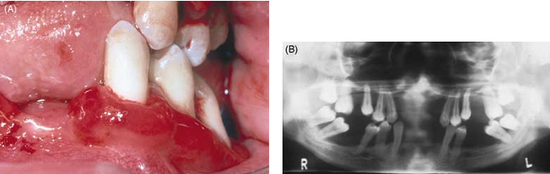
Partial loss of permanent teeth due to periodontal involvement in LAD

LAD-I is a disorder that involves a deﬁciency inthree membrane integrins. CD18/C11a (LFA-1) bindsto leukocytes and to endothelium via intercellularadhesion molecules (ICAM). CD18/CD11b (Mac-1)binds to ICAM and complement and facilitates complement-mediated phagocytosis. The function of thethird integrin, CD18/C11c is not well understood.The deﬁciency of these integrins prevents the neutrophil from adhering to the vessel wall at the site ofan infection. Therefore, in spite of a leukocytosis(20,000–80,000 cells/ml), neutrophils are unable tomigrate into the affected tissues. The clinical appearance is one of ulceration and necrosis of tissue, butwithout signs of purulence.
LAD-I is an inherited disorder that follows an autosomal recessive pattern. There have been just over600 cases described, each identiﬁed shortly afterbirth. More than 75% of children will die before theage of 5 if they do not receive a bone marrow transplant. The severity of the disease is based on therelative expression of CD18. Less than 1% of normalis described as severe, while 2.5–10% of normal isconsidered moderate to mild.Waldrop et al. described the oral conditionsin a family of six that suffered from LAD-I. The fatherand two children were homozygous for the condition. The children presented with acute gingivalinﬂammation of both primary and permanent dentitions, as well as gingival proliferation, recession,tooth mobility, and pathologic migration. The primary teeth were lost by age 4 andeither partial or total loss of the permanent teethoccurred by age 13. Bone loss was evident by age 3,and reached 60% by age eight. Histology of the gingival tissue showed a dense plasma cell inﬁltrate andthe marked absence of extravascular neutrophils.
LAD-II was ﬁrst described in 1992 by Etziomi et al. Only four cases have been documented to thispoint. Individuals with LAD-II are characterized byshort stature, mental retardation, and craniofacialabnormalities as well as recurrent infections. Theneutrophil defect in LAD-II is of the sialyl-Lewis xglycoprotein (CD15s), which allows neutrophils toattach to selectins (CD62E) on the endothelial surface. The end result is similar to LAD-1, and neutrophils are unable to migrate extravascularly.While the oral condition of these patients has notbeen reported, it can be assumed that the neutrophildefect is such that severe periodontal disease andtooth loss is likely.

Clinical signs in PapillonLevefre
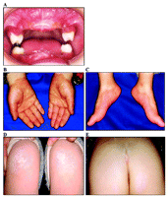

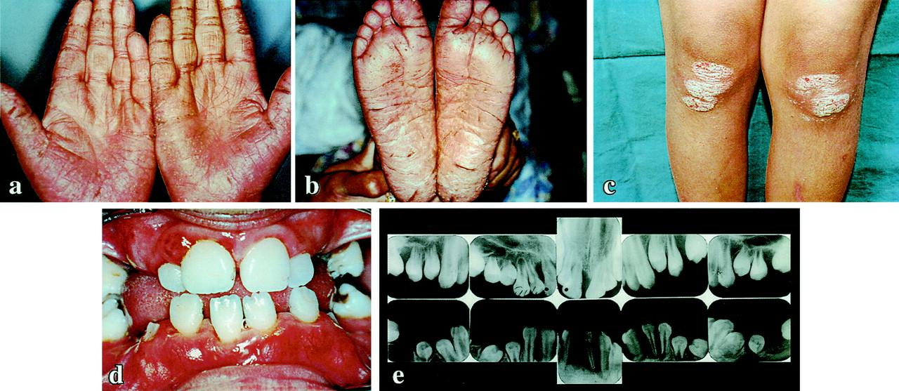
PAPILLON-LEFEVRE SYNDROME
The Papillon-Lefevre syndrome is described as a diffuse palmoplantar keratosis associated with aggressive periodontitis of both primary and permanentdentitions. The syndrome is named for the twoauthors who ﬁrst introduced this condition to theliterature in 1924. Papillon-Lefevre syndromeis a rare autosomal recessive disease with a prevalence of one to three cases per million in the generalpopulation. Consanguinity between parents hasbeen reported in at least one third of the reportedcases. The syndrome appears equally in males andfemales, and though most reported cases are in Caucasians, there does not seemto be a preference basedon race.The two essential features of Papillon-Lefevre syndrome are hyperkeratosis of the palms and soles(either diffuse or localized) and generalized rapiddestruction of the periodontal attachment apparatusresulting in premature loss of both primary and permanent teeth. Other ﬁndings, such as ectopic calciﬁcations of the falx cerebri and choroid plexus, increased susceptibility to infection, mental retardation, and endocrine disorders have been reported ina number of Papillon-Lefevre syndrome cases.
Papillon-Lefevre syndrome is but one of at least 19different forms of palmoplantar keratoedema. Whilesome of these other conditions may manifest withabnormalities of the teeth, Papillon-Lefevre syndrome is the only one associated with aggressiveperiodontitis.
A particular form of Papillon-Lefevre syndromehas been named the Haim-Munk syndrome. Whilealso characterized by palmoplantar keratosis andsevere early onset periodontitis, the Haim-Munk syndrome additionally presents with digital abnormalities. These include osteolysis of the distal phalanges,abnormal length and slenderness of the ﬁngers andtoes, and a claw-like hypertrophic deformity of thenails.
The association of Papillon-Lefevre syndrome withaggressive periodontitis, and in some cases recurrentinfections, led investigators to study neutrophil functions in Papillon-Lefevre syndrome patients. Severalauthors have reported a decrease in the chemotacticactivity of neutrophils, as well as decreased phagocytosis and intracellular killing of certain bacteria inPapillon-Lefevre syndrome patients. VanDyke et al. described neutrophil chemotaxis defectsin two patients with Papillon-Lefevre syndrome andnoted decreases in both random migration anddirected migration toward a chemotactic factor(FMLP). This alteration of polymorphonuclear

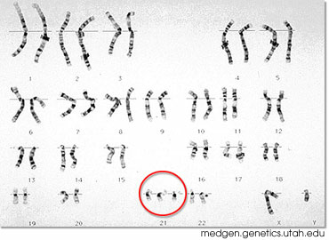

Chromosome 21 trisomy

neutrophil leukocyte function has not been observedin all cases. Both Lyberg and Schroeder et al. reportednormal neutrophil function including margination,chemotaxis, phagocytosis, degranulation of lysosomes and intracellular destruction in several children with Papillon-Lefevre syndrome who did notexhibit an increased susceptibility to infection.It is possible that both the greater vulnerability toinfection and neutrophil defects noted in somepatients may be a condition clinically distinct fromPapillon-Lefevre syndrome, or possibly secondary toan infection with a speciﬁc bacteria such as A. actinomycetemcomitans. Preus has hypothesizedthat the hereditary defect in Papillon-Lefevre syndrome is located in the epithelial barrier, which inthe gingival sulcus may lead to a reduced hostdefense against periodontopathogenic bacteria. Other authors have reported alterations incementum, an imbalance of collagenolytic activityin the periodontal ligament, and an increased osteoclastic activity in some Papillon-Lefevre syndromepatients. Taken together, these ﬁndings couldexplain the early onset aggressive periodontitis seen in Papillon-Lefevre syndrome patients even in theabsence of signiﬁcant neutrophil abnormalities.
DOWN’S SYNDROME
Down’s syndrome, one of the most common causesof mental retardation in children, was named afterthe English physician who in 1866 characterized theappearance and behavior of these patients. The distinct similarities in the features and conditions ofthe disease led early researchers to suspect a chromosomal aberration, and in the late 1950s Down’ssyndrome was speciﬁcally linked to trisomy of chromosome 21.
Among the clinical presentations of patientsafﬂicted with Down’s syndrome is the high prevalence of periodontitis. Cohen et al. reported ontheir investigation of 100 young patients with Down’ssyndrome and found that virtually all had somedegree of periodontal disease, ranging from severegingivitis in the youngest patients to periodontitiswith pocket formation and alveolar bone loss in theolder patients. The incidence of bone loss was foundto be twice that of a separate group of mentallyhandicapped patients, also institutionalized but nothaving Down’s syndrome.

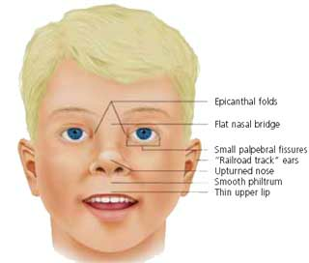

Extraoral features of Down syndrome

Johnson & Young used clinical examination,intra-oral photography, and radiographic survey toassess periodontal disease in 169 mentally retardedchildren both with and without Down’s syndrome.They reported that the extent of the periodontaldestruction was much greater in the Down’s syndrome children. Similarly, Orner found that boththe prevalence and severity of periodontitis wasgreater in individuals with Down’s syndrome than in their unaffected siblings.
In an extensive review of periodontal disease inDown’s syndrome, Roland-Bousma& Van Dijk examined both endogenous conditions and exogenous factors that may predispose affected patients toaggressive periodontitis. They divided the exogenousfactors into local factors, related mostly to oralhygiene, and secondary factors, such as tongue thrust,malocclusion, and lack of lip seal, which are commonfeatures of Down’s syndrome.
Among the endogenous factors that may exacerbatethe periodontitis in Down’s syndrome are defects inneutrophils. The ﬁrst cellular anomaly linked toDown’s syndrome was the tendency of the nucleusin neutrophils of Down’ssyndromepatientstobeconsistently less segmented than in other patientgroups. While the absolute numbers of neutrophils in Down’s syndrome patients are not signiﬁcantly different from healthy controls, some authorshave reported a preponderance of younger cell formsthat is independent of both the total leukocyte countand the relative number of neutrophils. Othershave suggested that this phenomenon is due to a tendency for the shortening of the half-life of circulatingneutrophils in patients with Down’s syndrome.
Neutrophil chemotaxis defects have also beenidentiﬁed in Down’s syndrome patients. Severalgroups have examined differences in neutrophilfunction between Down’s syndrome children and agroup of age matched controls. While normal neutrophil function was noted with regard to randommobility, there was a signiﬁcant reduction in chemotaxis in the Down’s syndrome children.Reports on the phagocytic ability of neutrophils inDown’s syndrome are mixed. While Rosner et al.noted a diminished ability for neutrophil phagocytosis of Candida albicans in Down’s syndrome children, other authors found normal neutrophilphagocytosis in similar study groups.

Inflammatory bowel disease
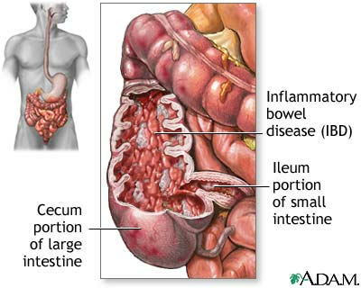

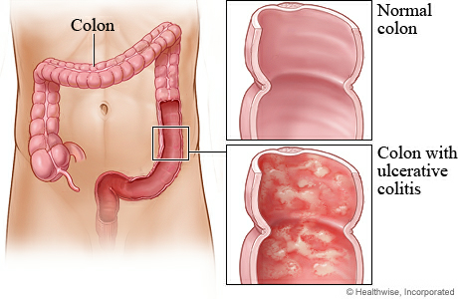

Another line of research in neutrophil function inDown’s syndrome patients has been the efﬁciency ofintracellular killing once phagocytosis has occurred.Reduced bacteriocidal capacity has been reported fora number of organisms, including S. aureus, Escherichia coli, and C. albicans. In contrast was thereport by Kretschmer et al. that found the intracellular killing of Streptococcus pyogenes in Down’s syndrome neutrophils to be normal, and a wide range ofbacteriocidal capacity of these neutrophils towardS. aureus. Results of nitroblue tetrazoliumreduction testing in neutrophils of Down’s syndromepatients has also been mixed, with lower thanexpected values found by Tan et al. and Kretschmeret al. and normal values noted by Seger and Barkin. Taken together, these studies suggest a great variation in the oxidative metabolicpotential of neutrophils in Down’s syndromepatients.
Finally, in addition to the well-studied neutrophildeﬁciencies in Down’s syndrome patients, stillanother line of research has investigated the relationship between neutrophil derived cytokines and theperiodontitis lesions of Down’s syndrome patients.Halinen et al. found increased levels of neutrophilcollagenase (MMP-8) in the saliva and gingival crevicular ﬂuid of Down’s syndrome patients. Theseﬁndings suggest that the active MMP-8 derived fromtriggered neutrophils and/or cytokine induced periodontal ﬁbroblasts may reﬂect the periodontaldestruction seen in patients with Down’s syndrome.
INFLAMMATORY BOWEL DISEASE
Inﬂammatory bowel disease comprises two chronicclinical entities: Crohn’s disease and ulcerative colitis. Inﬂammatory bowel disease has a reportedannual incidence in the U.S. population of 5–15/100,000 and affects men and women fairly equally.
While the onset of symptoms is not totally understood, inﬂammatory bowel disease is likely due to acomplex combination of genetic, environmental, andbacterial triggering events that activate both immuneand non-immune systems within the intestine. Acell-mediated immune response induces effectorT cells and activates macrophages, neutrophils, andeosinophils, while a humoral response stimulates theproduction of antibodies. Through secretion of soluble mediators and expression of cell adhesion molecules, immune and non-immune cells exchangesignals, resulting in a further ampliﬁcation of antibodies, cytokines, growth factors,

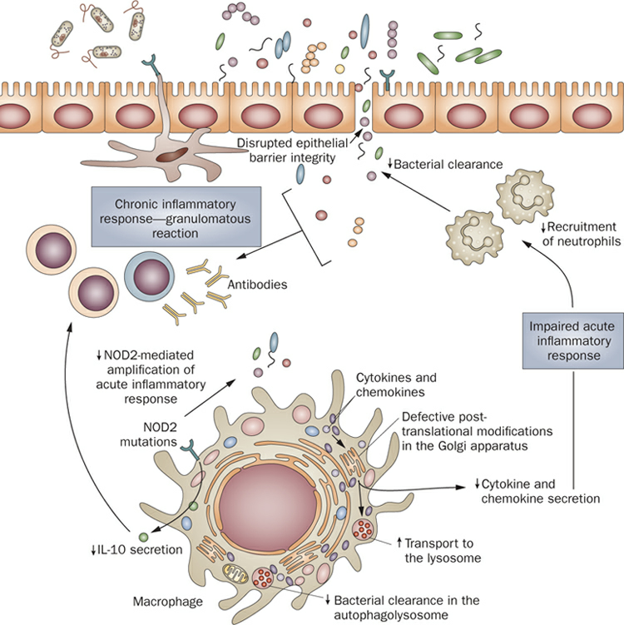
Bacterial clearance in Crohn’s disease

prostaglandins,leukotrienes, reactive oxidative metabolites, nitricoxide, and proteolytic enzymes that culminate inchronic inﬂammation and tissue damage.
The similarities between the etiopathogenesis ofperiodontal disease and inﬂammatory bowel diseaseare evident. Both involve an excessive exposure toantigens fromthe indigenous microﬂora, a persistentstimulation of protective immune systems, and amodifying inﬂuence of environmental factors suchas smoking. Whether or not patients with inﬂammatory bowel disease are at increased risk forperiodontitis, and whether any increased incidenceis related to defects in neutrophil function, is a subject of some debate.
Theauthors determined that although the prevalence ofperiodontal disease was slightly higher in patientswith inﬂammatory bowel disease, the severity of periodontal disease was less than had been reported forthe general population. Their conclusion was thatsevere periodontal disease and inﬂammatory boweldisease are two unrelated disease entities that canoccur in the same individual.
A link between periodontitis and neutrophil defectsin inﬂammatory bowel disease patients has also beenproposed. While reports have identiﬁed depressedneutrophil chemotaxis in patients with inﬂammatorybowel disease, these studies have beendifﬁcult to interpret because of differences in methodology and classiﬁcation. Van Dyke et al. performed both microbiological studies of periodontal pockets and laboratory studies of neutrophil function in 20 inﬂammatory bowel disease patients. Theyfound neutrophil chemotaxis consistently suppressedin inﬂammatory bowel disease patients with periodontitis and ulcerative colitis, but not in patients without periodontitis, or those with periodontitis andCrohn’s disease. Bacterial studies determined thatthe predominant organism from the periodontal ﬂoraof all inﬂammatory bowel disease patients was asmall motile rod identiﬁed as a Campylobacter species. The authors speculated that neutrophil chemotaxis defects identiﬁed in some of the inﬂammatorybowel disease patients could be attributed in part tothe antigenic load of periodontopathogens known toinhibit neutrophil chemotaxis.
Another possible role of neutrophils in inﬂammatory bowel disease patients with periodontitis is theenhanced neutrophil activity noted in some patients.In 1978, Lamster et al. reported enhanced phagocytic ability of neutrophils from a patient withCrohn’s disease and

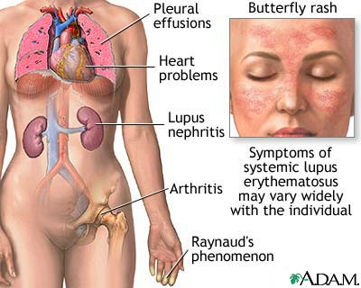

Systemic lupus erythhematosus

severe periodontitis. Otherreports have identiﬁed increases in both leukotrieneB4 production and overall metabolic activity in neutrophils from inﬂammatory bowel disease patients. This seems to represent the most currentline of research in inﬂammatory bowel disease, whereinterest in neutrophil function now seems to centeraround the neutrophil’sroleinamplifyingthe inﬂammatory response. Based on the current literature,it does not appear conclusive that a systemic neutrophil disorder leads to a higher incidence of periodontitis in inﬂammatory bowel disease patients.
SYSTEMIC LUPUS ERYTHEMATOSUS
Systemic lupus erythematosus is a chronic autoimmune disease that affects the connective tissue andmultiple organ systems. The disease is mostcommon in women, and is likely due to a combination of genetic factors and environmental triggeringevents. Systemic lupus erythematosus ranges inseverity from a mild disease, with rash and arthritis,to a serious illness characterized by renal failure andsigniﬁcant neurological disturbances. The prevalence of systemic lupus erythematosus in NorthAmerica and Northern Europe has been estimatedat about 40 cases per 100,000 population.
An increased incidence of infection in systemiclupus erythematosus patients is an often-reported ﬁnding. It is estimated that at least 50% of systemic lupuserythematosus patients will suffer an infection duringthe course of the disease, and infection is among themost cited reasons for hospital admission.
Among the hematologic disorders thatmay explainthis increased incidence of infection are a tendencyto neutropenia and various neutrophil abnormalities.Patients with systemic lupus erythematosus canexhibit diminished neutrophil formation. Otherpossible causes for neutropenia include anti-neutrophil antibodies and enhanced neutrophil apoptosis. Speciﬁc neutrophil defects have also beenreported. While reports of deﬁciencies in neutrophilchemotaxis are mixed, most of the evidence suggeststhat impaired neutrophil phagocytosis is present insome systemic lupus erythematosus patients.
In spite of the numerous reports of oral lesions,and the increased overall susceptibility to infectionthere is little information on the periodontal status ofsystemic lupus erythematosus patients. In an uncontrolled study of 16 women with systemic lupuserythematosus, Rhodus&

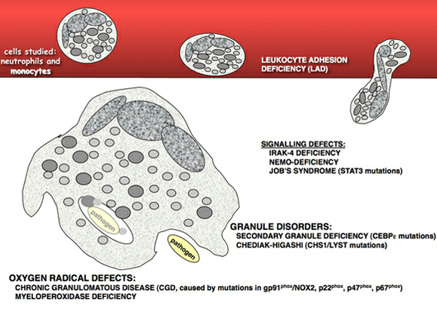

Myeloperoxidase deficiency

Johnson found periodontitis in all but one of them. More recently, Novoet al. observed periodontitis in 60% of 30 systemic lupus erythematosus patients compared to50% in a control group with rheumatoid arthritis.
Finally, in a comparison of the periodontal statusof systemic lupus erythematosus patients with age-and sex-matched controls,Mutlu et al. found that thesystemic lupus erythematosus patients had signiﬁcantly shallower probing depths than the controlgroup. Considering these reports, and the factthat the combined number of systemic lupus erythematosus subjects in these three studies is less than100, it is very difﬁcult to ﬁnd evidence for anincreased prevalence of periodontal disease in systemic lupus erythematosus patients.
MYELOPEROXIDASE DEFICIENCY
Myeloperoxidase is a hemeprotein located in theazurophilic lysosomes of neutrophils and monocytes.Myeloperoxidase’s functional signiﬁcance is itsability to oxidize chloride ions, which in the presenceof H2O2 leads to the production of the microbiocidalagent hypochlorous acid (HOCl). The myeloperoxidase–H2O2–Cl system represents the mostefﬁcient component of the oxygen-dependent anti-microbial system of neutrophils, with effects againsta wide range of bacteria, fungi, and viruses.
Few cases of myeloperoxidase deﬁciency had beenreported until the mid 1970s, when ﬂow cytometrybegan to be used routinely to enumerate leukocytesin clinical specimens. In this technique, myeloperoxidase activity was used for the speciﬁc staining ofneutrophils, and the surprising frequency of thosefound to have myeloperoxidase deﬁciency was determined to be about one in 4,000 persons. Myeloperoxidase deﬁciency can be both congenitalor acquired through a number of conditionsincluding hematological neoplasms, iron deﬁciency,lead intoxication, renal transplants, severe infectious diseases, and diabetes mellitus.
In spite of the central role of myeloperoxidase inthe oxidative killing process within phagocytic cells,most of the individuals with myeloperoxidase deﬁciency have no increased risk for infection or otherclinical manifestations of disease. In fact,the rate of severe infections in individuals with myeloperoxidase deﬁciency is less than 5%, althoughthere have been reports of severe visceral candidalinfections in people with myeloperoxidase deﬁciencyand diabetes mellitus. It has been speculated that alternative oxidative pathways exist thatovercome the

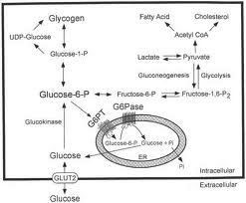

Glycogen Storage disease
myeloperoxidase-dependent mechanism; however, these alternative pathways may be lesseffective in eliminating certain fungi such as Candidaor Aspergillus species.
Reports of oral manifestations of myeloperoxidasedeﬁciency are limited to case reports. Okuda et al.reported deep mucocutaneous candidiasiswith oral lesions in a 32-year-old woman with myeloperoxidase deﬁciency. More recently, Edgertondescribed palatal candidiasis in a 64-year-old womanwith myeloperoxidase deﬁciency and Crohn’s disease. The only report of periodontitis and myeloperoxidase deﬁciency was made by D’Angelo et al.who described a case of generalized aggressiveperiodontitis in a 3-year-old girl with myeloperoxidase deﬁciency and Papillon-Lefevre syndrome. Thischild, who had a history of recurrent infections, wasalso noted to have defective neutrophil chemotaxis.Based on these reports, especially considering thatmyeloperoxidase deﬁciency is not a rare ﬁnding, it isnot possible to establish a conclusive link betweenmyeloperoxidase deﬁciency and periodontal disease.
GLYCOGEN STORAGE DISEASE TYPE 1B
The glycogen storage diseases comprise a group of atleast 18 inherited disorders caused by abnormalitiesof enzymes regulating the synthesis and degradationof glycogen. Glycogen storage disease type 1b isan autosomal recessive disorder caused by a defect inthe glucose-6-phosphate transporter protein. As theresult of this defect, glucose-6-phosphate cannot betransported across the endoplasmic reticulum ofhepatocytes, preventing the glycogen from beingmetabolized into glucose. Glycogen is thendeposited in the liver with a uniform distension ofliver cells. Glycogen storage disease type 1b ismost often diagnosed in infancy or early childhood.
Among the prominent clinical features are a ‘‘doll-like’’ facial appearance, stunted growth, hypoglycemia, ketosis, lactic acidosis, hyperlipidemia, gout,and bleeding episodes brought on by impaired plateletfunction secondary to metabolic disorders.Additional distinguishing features of glycogen storage disease type 1b are neutropenia, neutrophil dys-function, and an increased susceptibility to infection.The neutropenia, either constant or cyclic, is suspected to be a consequence of altered myeloidmaturation. Neutrophil abnormalities identiﬁedin glycogen storage disease type 1b patients includedefects in both random and directed PMN migration.

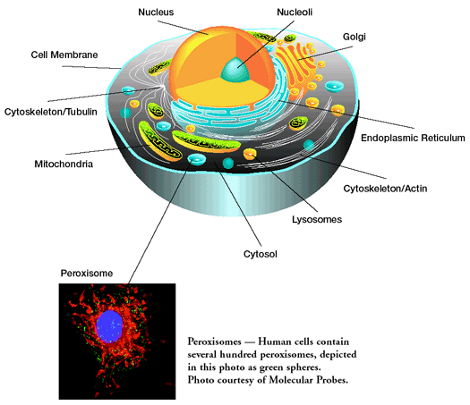

Peroxisomes

Koven et alstudied laboratory ﬁndings on several patients with glycogen storage disease type 1b,and found defects in motility, chemotaxis, nitrobluetetrazolium test reduction, and bactericidal activity.The authors speculated that these results, similar toﬁndings in other studies, suggest a generalized metabolic neutrophil defect in glycogen storage diseasetype 1b patients. It is possible that a block in thetransport of glucose-6-phosphate into the endoplasmic reticulum of neutrophils, similar to the defectknown to exist in hepatocytes, may interrupt themetabolic pathways necessary for neutrophil function. The range of susceptibility to infection in thesepatients could then be explained by whether the defect in the glucose-6-phosphate system is eitherpartial or complete. Since the glucose-6-phosphate gene is not expressed in myeloid cells, however, neutrophil abnormalities in glycogen storagedisease type 1b may not be totally attributable todysfunction within this system.
Still others have noted that disturbed neutrophilfunction in glycogen storage disease type 1b patientsmay be closely linked to neutropenia. Visser et al.conducted a record review of 57 cases of glycogen storage disease type 1b and noted that 87% of thepatients had neutropenia at least intermittently, andthat all patients with neutropenia had concomitantneutrophil abnormalities.
Reports of oral disease in glycogen storage diseasetype 1b patients are common, and include oralulceration, candidiasis, gingivitis, and periodontitis. Visser et al. noted ‘‘peri-oral infections’’ in therecords of 37 of 57 glycogen storage disease type 1bpatients reviewed, all of whom had neutropenia and defective neutrophil function. Dougherty &Gataletto described a case of generalized aggressive periodontitis in a child with glycogen storagedisease type 1b. Based on the available information,it can be determined that the neutropenia and neutrophil dysfunction noted in some patients with glycogen storage disease type 1b leave them at risk fordeveloping periodontitis.
ACATALASIA
Acatalasia, or acatalasemia, is a rare autosomalrecessive disorder that has been reported in isolatedfamilies from a number of different countries. Todate, most reported cases have been from Japan (orof Japanese ancestry), and involve some degree ofconsanguinity.Patients with acatalasia have a deﬁciency of erythrocyte catalase. Catalases in general are enzymesthat

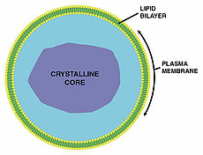
Peroxisomes in Acatalasia

catalyze the decomposition of hydrogen peroxide (H2O2) to oxygen and water. If this enzyme isdeﬁcient, H2O2 may accumulate in cells and predispose for tissue damage. In mammals, high catalaselevels are found in the liver, kidney, and erythrocytes.In erythrocytes, most catalase is normally found inthe cytosol, with a small fraction incorporated intothe erythrocyte membrane.
Effects of catalase deﬁciency have also beenreported for neutrophils. An impaired respiratoryburst has been noted when neutrophils from someacatalasia patients are pre-exposed to a hydrogenperoxide generating system, leading to speculationthat the inability to fully metabolize hydrogen peroxide may lead to impaired neutrophil function. That unmetabolized H2O2 may have a cumulative ill effect on other cellular structures has also been recently discussed by Goth et al., who reportedan increased incidence of type 2 diabetes in acatalasia families, possibly due to long-term H2O2 effectson pancreatic cells.
While patients with acatalasia are not generallyprone to infections, approximately 25–50% sufferan oral condition called Takahara’sdisease,characterized by painful ulcerations of the gingiva and tonsillar lacunae. Interestingly, only one report of thiscondition exists in the dental literature. In 1979, Delgado & Calderon described the oral condition oftwo Peruvian siblings with acatalasia to consist ofnecrotizing ulcerative periodontitis-like lesions complete with ulcerations of the papillary gingiva andadvanced alveolar bone loss. A predominance of catalase-negative pneumococci (known to produce H2O2)cultured from necrotic gingival tissue led the authorsto speculate on a possible role for increased levels ofhydrogen peroxide in causing the tissue damage.
In summary, the medical literature suggests that anumber of patients with acatalasia are at risk forperiodontal disease. Whether that increased susceptibility is due to neutrophil dysfunction, or is even theresult of cumulative damage to neutrophils by unmetabolized H2O2, has not been established.

CONCLUSIONS

Although rare in occurrence, an association betweenvarious systemic conditions characterized by neutrophil dysfunction and periodontal disease does exist. While this association is clearly deﬁned in most ofthe systemic disorders listed above, for others deﬁnitive evidence is lacking. Some of these conditionshave been so rarely reported that no extensive casestudy exists (LAD-II, acatalasia). For others, areported increase in the incidence of periodontitisfrom case reports has not held up under the scrutinyof more controlled studies (systemic lupus erythematosus, inﬂammatory bowel disease). The periodontal treatment for patients with periodontitisrelated to neutrophil disorders has been empiricaland without consistent success. Localized debridement, local and systemic antibiotics, antimicrobialrinses, subgingival irrigation, selective extractionand frequent periodontal maintenance have all beenattempted. Unfortunately, for those systemic conditions most associated with neutrophil disorders andperiodontitis, the end result is usually tooth loss.

REFERENCES

- Carranza 10th edition
- Deas et al. Systemic disease and periodontitis:manifestations of neutrophil dysfunction. Periodontol 2000, 32, 2003, 82–104.
- Nussbaum G, Shapira L: How has neutrophil research improved our understanding of periodontal pathogenesis? J ClinPeriodontol 2011; 38 (Suppl. 11): 49–59.
- Sahingur et al. Analysis of host responses and risk for disease progression. Periodontol 2004;34;57-83.
- Ryder, M. I. (2010) Comparison of neutrophil functions in aggressive and chronic periodontitis. Periodontology 2000 53, 124–137.
- Abodi GM. Refractory periodontitis population characterized by a hyperactive oral neutrophil phenotype. J Periodontol. 2011;82(5):726-33.

